University of Moratuwa

Department of Electronic & Telecommunication Engineering

**

A.M.V.M.Amarasinghe 200027R

Contents

Enclosure designs 3

1. Design 1 3

2. Design 2 4

3. Design 3 5

4. User centered design -Design 4 6

List of contributors to my enclosure design 7

Design criteria for choosing an Enclosure design 7

1. Block diagrams 9

Block diagram 1 9

2. Block diagram 2 10

3. Block diagram 3 11

4. Block diagram 4 12

List of contributors to my block diagram designs 13

Design criteria for choosing a Block diagram. 13

User centered design 15

Survey 15

Survey results 16

Some descriptive answers 17

What we changed after getting the user needs. 19

Changes in enclosure design 19

Changes in block diagram 19

# Enclosure designs

## Design 1

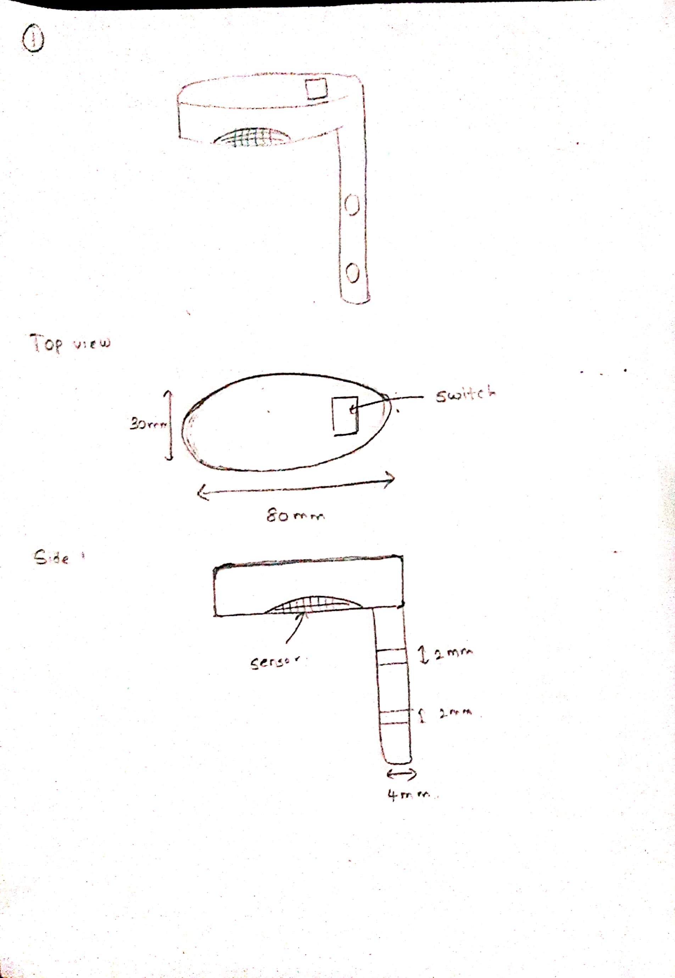

Camera is removed.

Only powered by the battery.

## Design 2

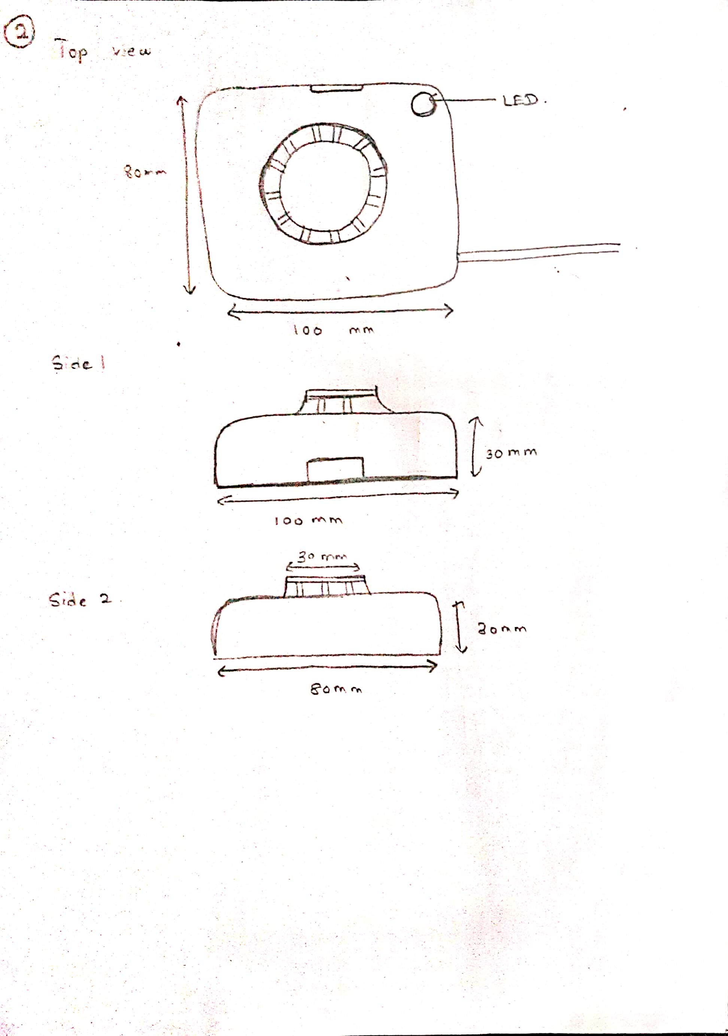

Camera removed.

Added some indicator LEDs.

## Design 3

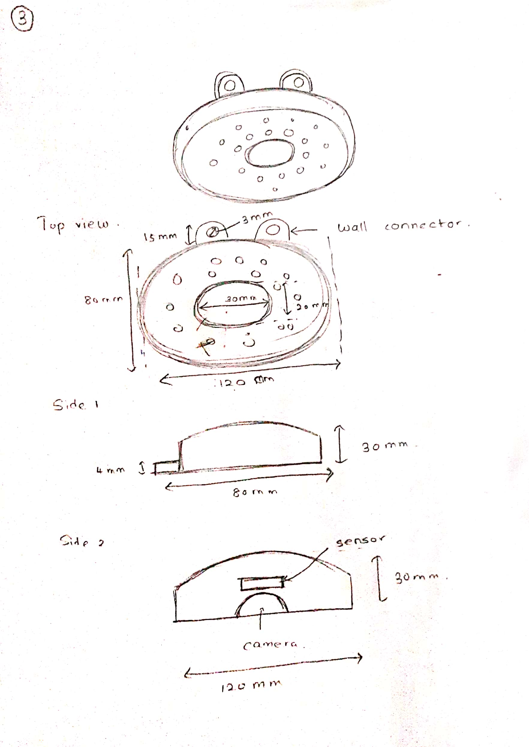

Added a wall connector.

Camera added.

## User centered design -Design 4

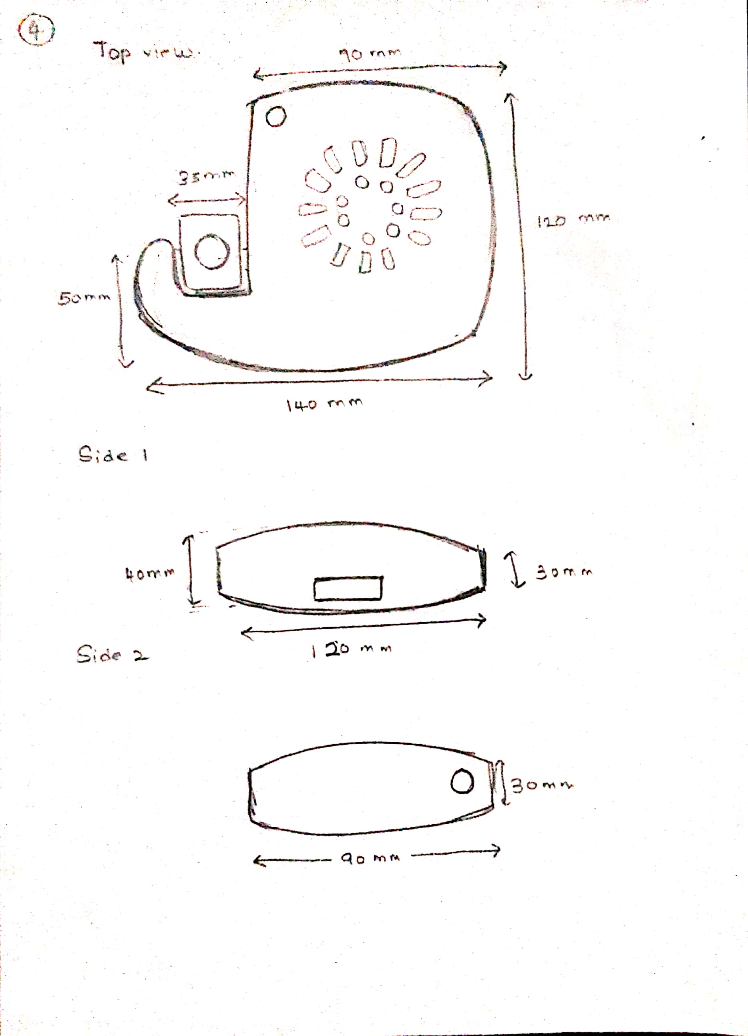

Added the camera.

Added indicator LEDs.

Added a part to adjust camera.

# List of contributors to my enclosure design

|  |  |
| --- | --- |
| Amarasinghe A.M.V.M | 200027R |
| Bandara H.M.C.N.K | 200063X |
| Himeka S.H.D | 200222K |
| Kapukotuwa P.B.K.S.G | 200287L |
| LUCKSHAN G.W.C.M. | 200358G |
| Prabuddhika M.W.R | 200473E |
| Pramuditha R.M.I.D | 200477U |
| Tilakarathna.U.A | 200664P |

# Design criteria for choosing an Enclosure design

Do not meet the criteria -0

Partially meet the criteria - 5

Fully meet the criteria -10

|  |  |  |  |  |
| --- | --- | --- | --- | --- |
| Criteria | Design 1 | Design 2 | Design 3 | Design 4 |
| 1. Functionality | 6 | 7 | 8 | 8 |
| 1. Aesthetics | 7 | 6 | 8 | 9 |
| 1. Size and Form Factor | 7 | 9 | 8 | 8 |
| 1. Ease of Assembly | 8 | 7 | 7 | 8 |
| 1. Material Compatibility | 7 | 6 | 7 | 7 |
| 1. Accessibility | 6 | 8 | 8 | 8 |
| 1. Structural Integrity | 7 | 7 | 8 | 8 |
| 1. Ventilation and Heat Dissipation | 8 | 7 | 6 | 9 |
| 1. Mounting Options | 8 | 8 | 8 | 8 |
| 1. Cost-Efficiency | 8 | 7 | 7 | 7 |
| Total marks | 72 | 72 | 75 | 80 |

**Conclusion**

According to our criteria the user centered design is selected with highest mark of 80.

How we gave marks for our criteria

1. Functionality: Ensure that the design accommodates the necessary components, such as the sensors, buzzer, and camera, in an efficient and functional manner.

2. Aesthetics: Choose a design that is visually appealing and complements the overall aesthetics of a kitchen environment.

3. Size and Form Factor: The design should be compact and suitable for mounting on a wall without being obtrusive or taking up excessive space.

4. Ease of Assembly: for a design that is easy to assemble, with clear instructions and minimal complexity in terms of connecting the various components.

5. Material Compatibility: Select a design that can be printed using materials compatible with the intended functionality and durability requirements of the device.

6. Accessibility: Consider a design that allows easy access to replaceable components, such as the sensors or batteries, for maintenance or replacement purposes.

7. Structural Integrity: Ensure that the design provides sufficient structural support to withstand the weight of the device and any potential external forces or impacts.

8. Ventilation and Heat Dissipation: Take into account the need for proper ventilation and heat dissipation to prevent overheating of the internal components.

9. Mounting Options: Choose a design that offers versatile mounting options, allowing the device to be securely attached to different types of walls or surfaces.

1. Cost-Efficiency: Consider the cost of printing the design and any associated material or assembly costs, aiming for an affordable and cost-effective solution.

# Block diagrams

## Block diagram 1

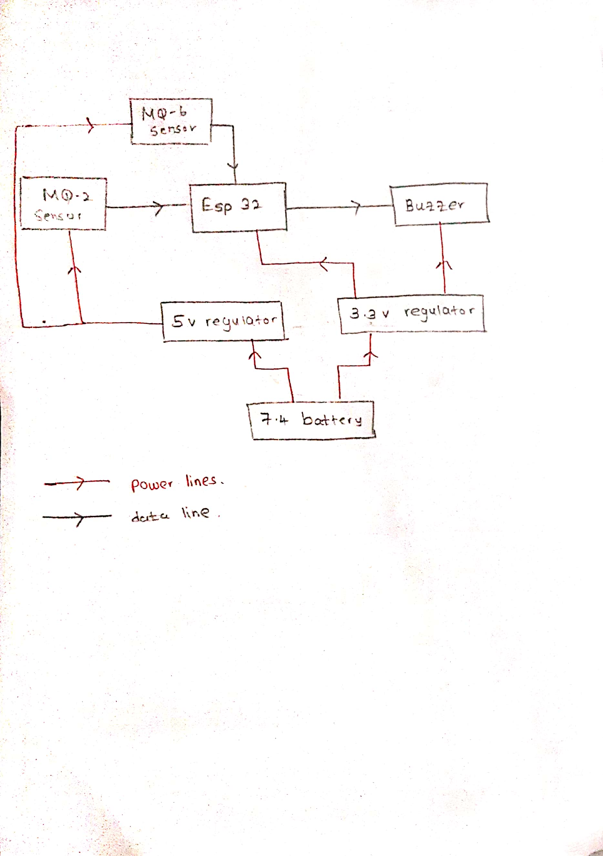

Camera removed.

Only powered using battery.

Mobile app is removed.

## Block diagram 2

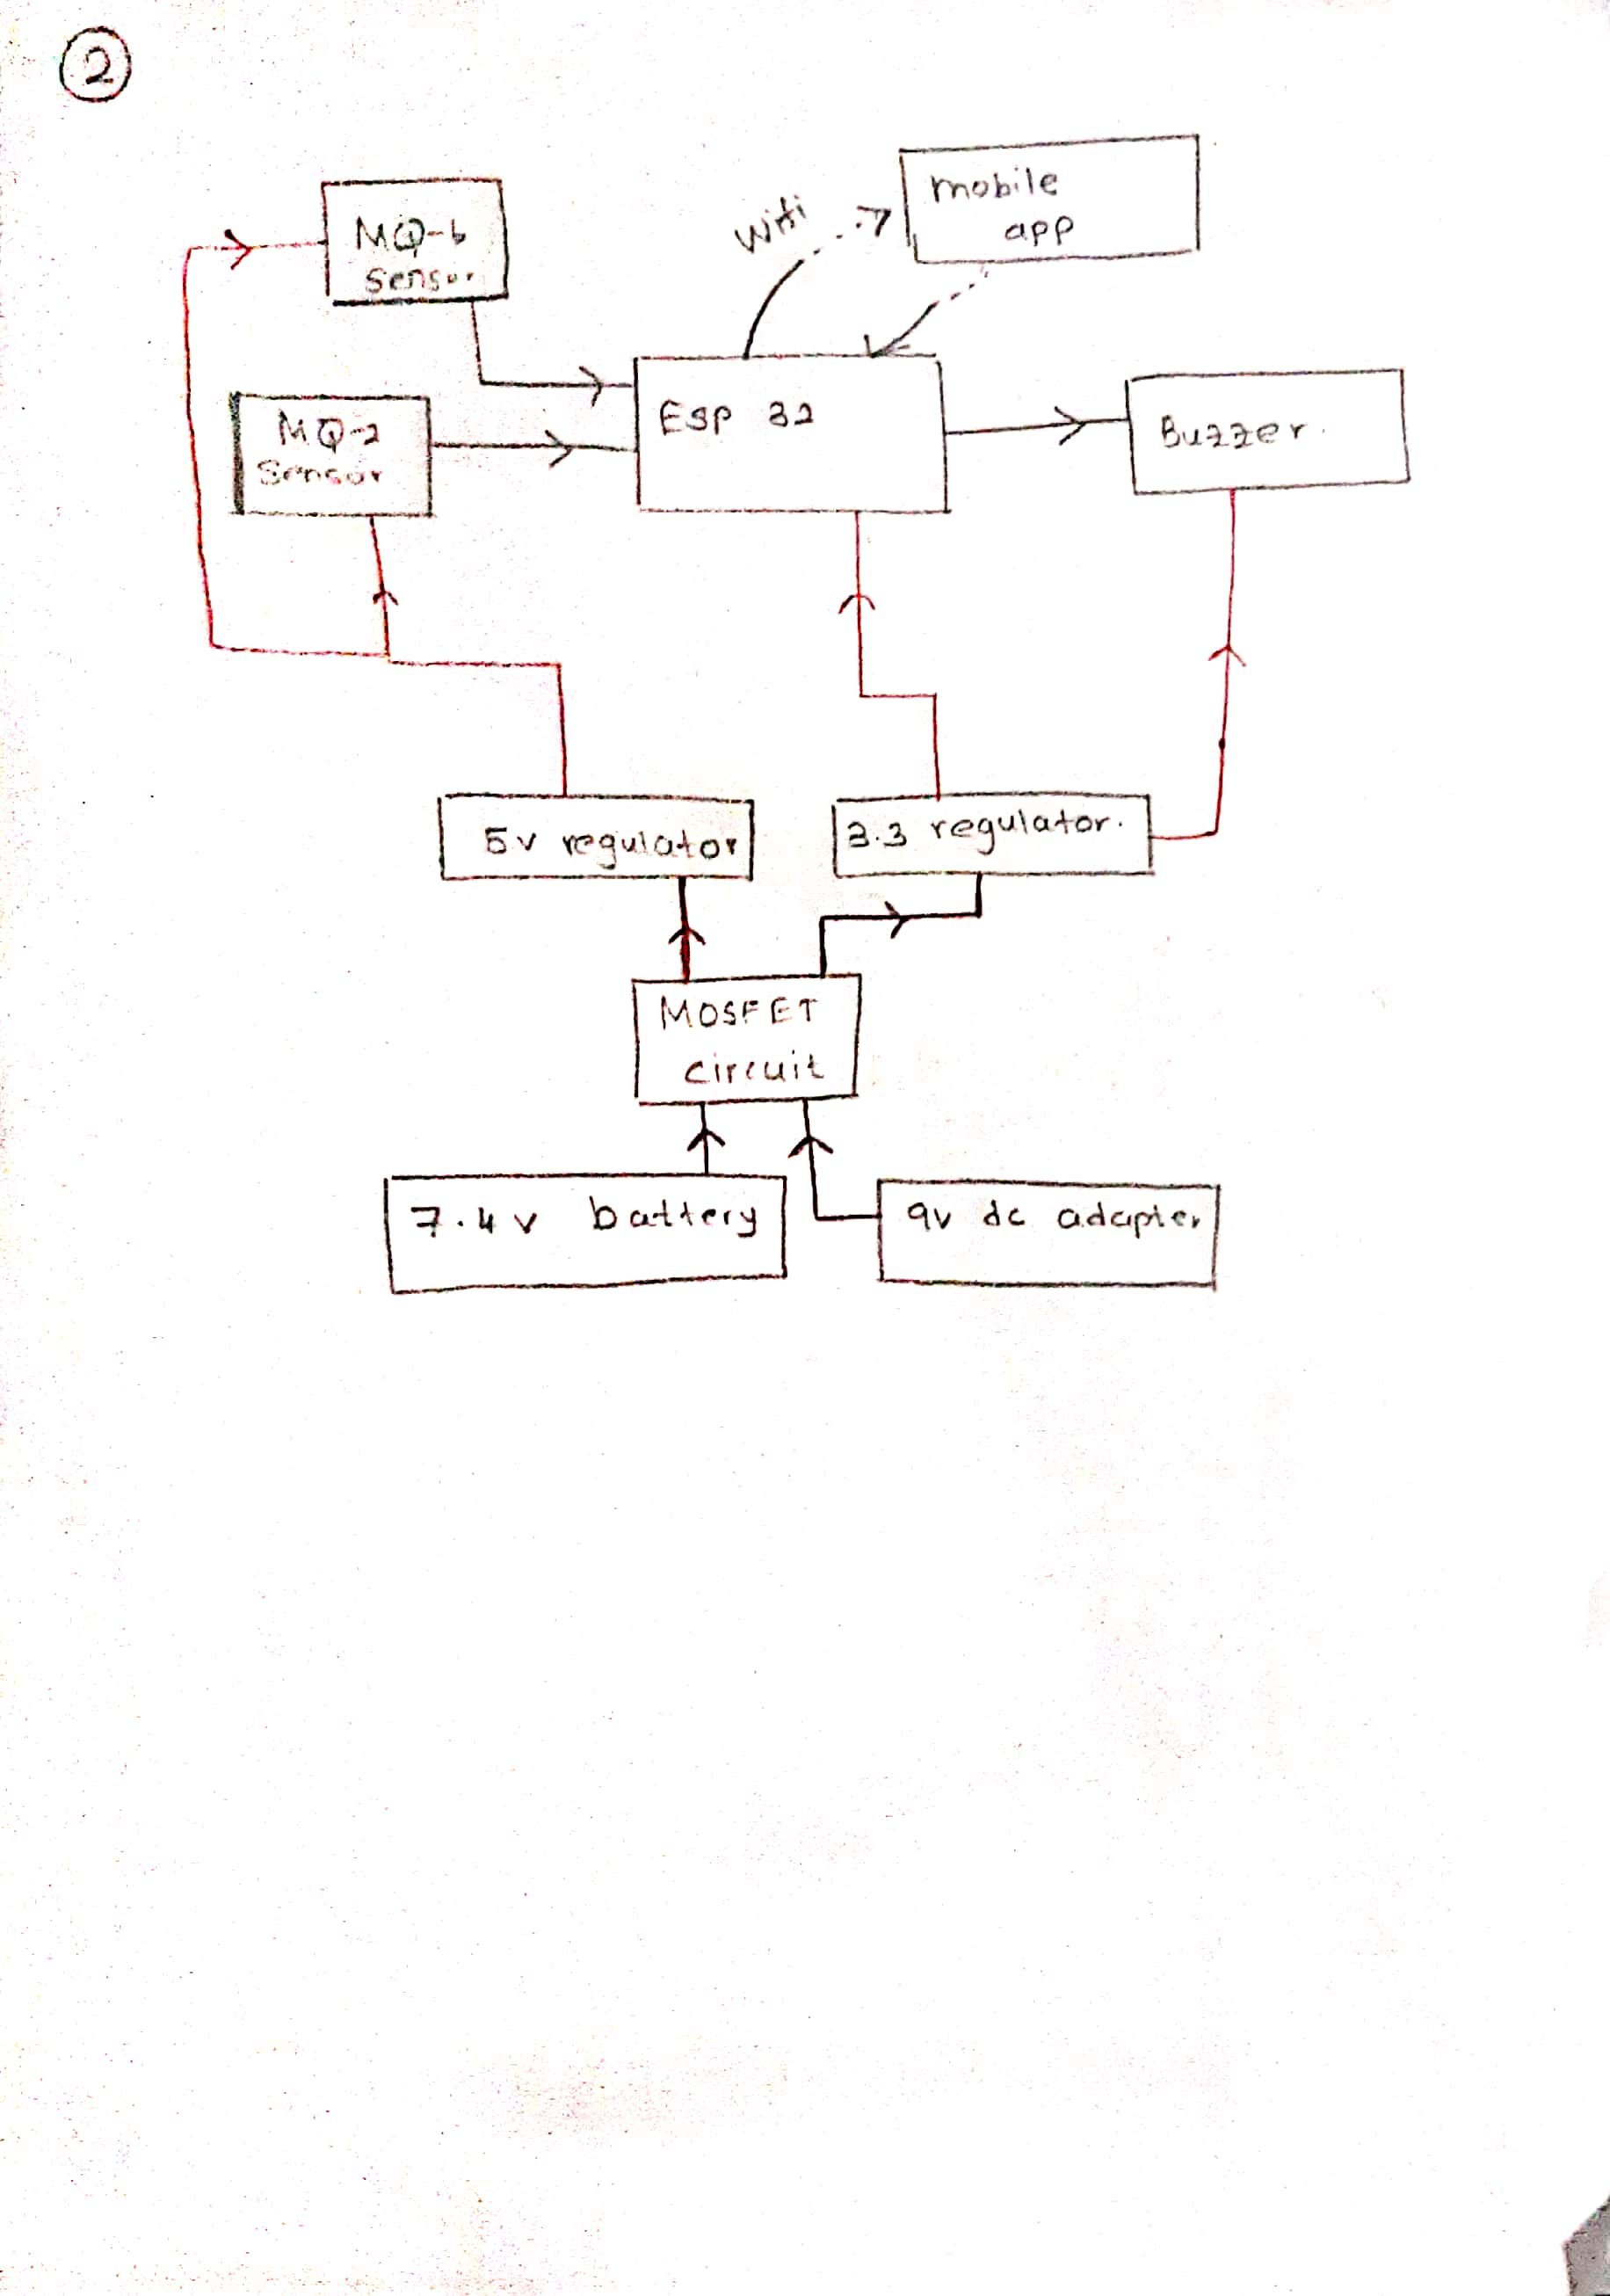

Camera removed.

Added 9v dc adaptor with a mosfet circuit.

Added the mobile app.

## Block diagram 3

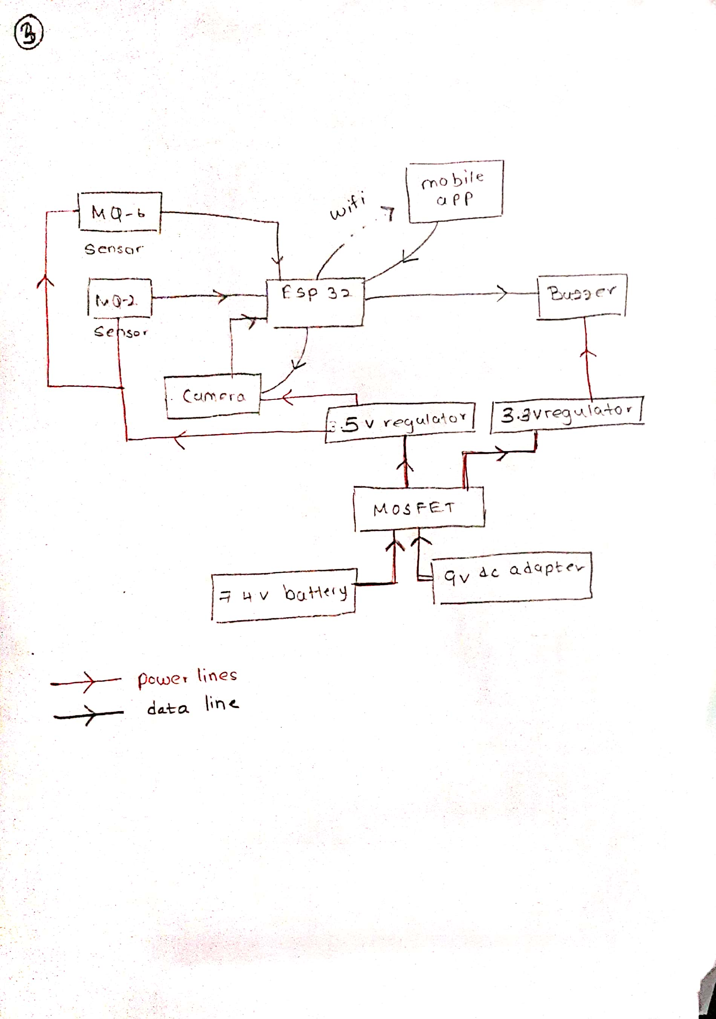

Camera is added.

9v dc adaptor is added.

MOSFET circuit is added.

Mobile app is added.

## Block diagram 4

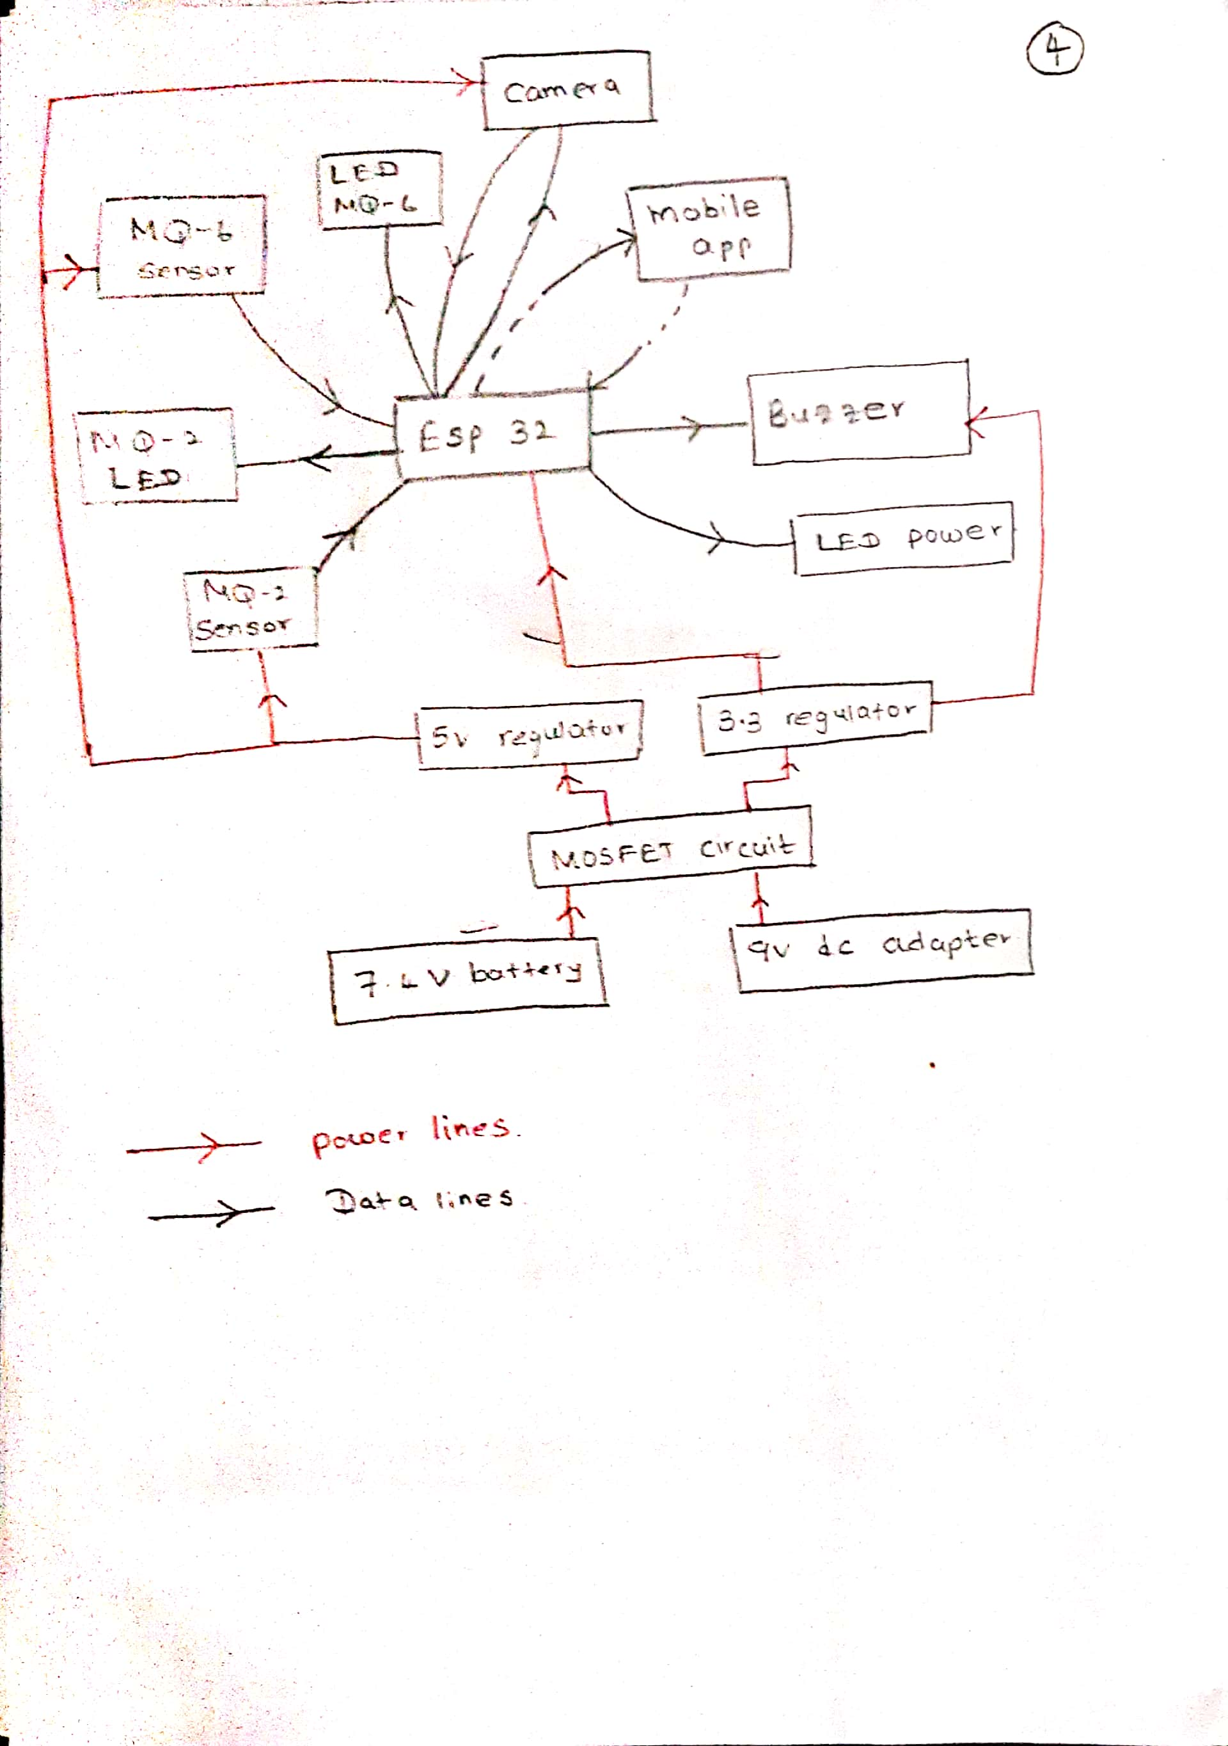

Camera is added.

9v dc adaptor is added.

MOSFET circuit is added.

Mobile app is added.

LED indicators are added.

# List of contributors to my block diagram designs

|  |  |
| --- | --- |
| Amarasinghe A.M.V.M | 200027R |
| Bandara H.M.C.N.K | 200063X |
| Himeka S.H.D | 200222K |
| Kapukotuwa P.B.K.S.G | 200287L |
| LUCKSHAN G.W.C.M. | 200358G |
| Prabuddhika M.W.R | 200473E |
| Pramuditha R.M.I.D | 200477U |
| Tilakarathna.U.A | 200664P |

# Design criteria for choosing a Block diagram.

Do not meet the criteria -0

Partially meet the criteria - 5

Fully meet the criteria -10

|  |  |  |  |  |
| --- | --- | --- | --- | --- |
| Criteria | Block diagram 1 | Block diagram 2 | Block diagram 3 | Block diagram 4 |
| Functionality | 7 | 7 | 8 | 9 |
| Clarity and Simplicity | 8 | 7 | 7 | 8 |
| Component Interconnections | 7 | 7 | 8 | 8 |
| Scalability | 7 | 8 | 9 | 9 |
| Modularity | 8 | 7 | 7 | 7 |
| Power Management | 8 | 8 | 7 | 9 |
| Data Flow | 7 | 7 | 8 | 8 |
| Safety Considerations | 7 | 8 | 9 | 9 |
| Compatibility | 8 | 7 | 7 | 9 |
| Compliance and Standards | 7 | 7 | 7 | 8 |
| Total marks | 74 | 73 | 77 | 84 |

**Conclusion**

We choose the block diagram 4 by the highest mark of 84.

How we gave marks for our criteria

1. Functionality: The block diagram should clearly represent the various functional components of the device, such as the sensors, buzzer, camera, microcontroller, and power supply.

2. Clarity and Simplicity: Choose a block diagram that is easy to understand and visually clear, allowing for easy interpretation of the device's overall architecture.

3. Component Interconnections: Ensure that the block diagram illustrates the connections and interactions between different components, indicating how they communicate and work together.

4. Scalability: Consider a block diagram that allows for scalability and future expansion, enabling additional features or functionalities to be easily incorporated into the device's design.

5. Modularity: Opt for a block diagram that demonstrates a modular design approach, with well-defined blocks representing individual components or subsystems.

6. Power Management: The block diagram should depict how power is distributed and managed within the device, including any voltage regulation or power conditioning modules.

7. Data Flow: Ensure that the block diagram illustrates the flow of data between different components, including sensor data acquisition, processing, and communication with the mobile app.

8. Safety Considerations: Take into account the inclusion of safety features or modules in the block diagram, such as emergency shut-off mechanisms or backup power systems.

9. Compatibility: Consider a block diagram that aligns with the compatibility requirements of the device, such as compatibility with specific communication protocols (e.g., Wi-Fi) or integration with existing smart home systems.

10. Compliance and Standards: Ensure that the block diagram adheres to relevant industry standards and regulations, especially those related to safety, data privacy, and electromagnetic compatibility (EMC).

# User centered design

## Survey

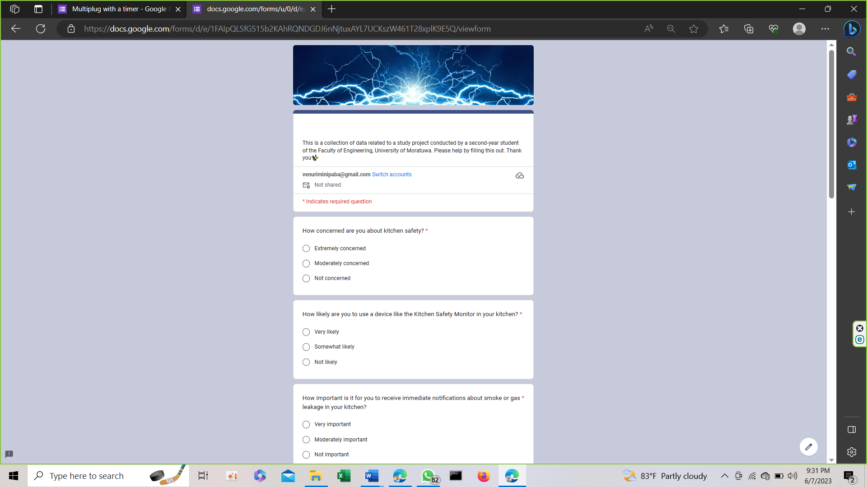

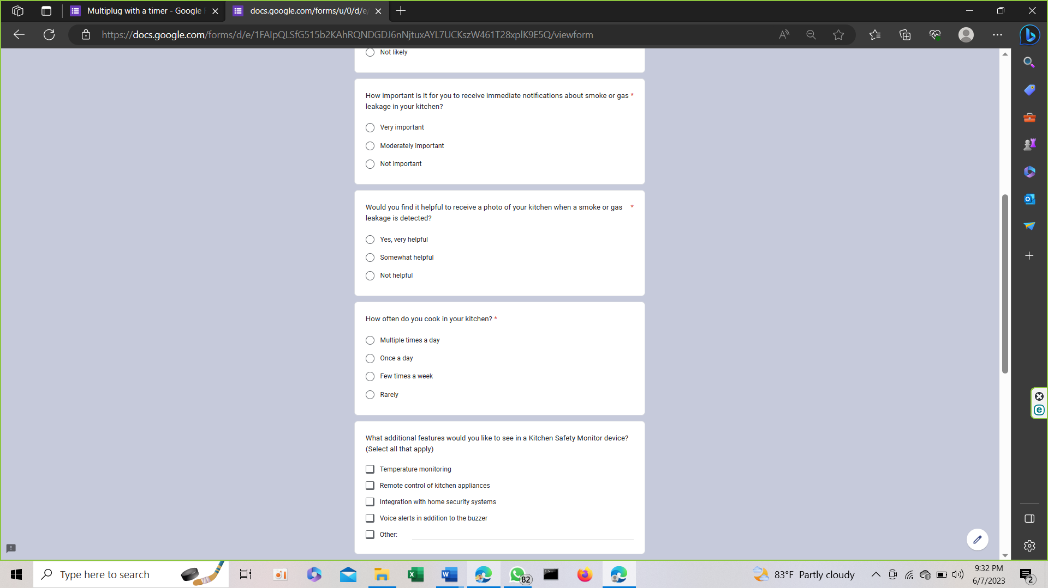

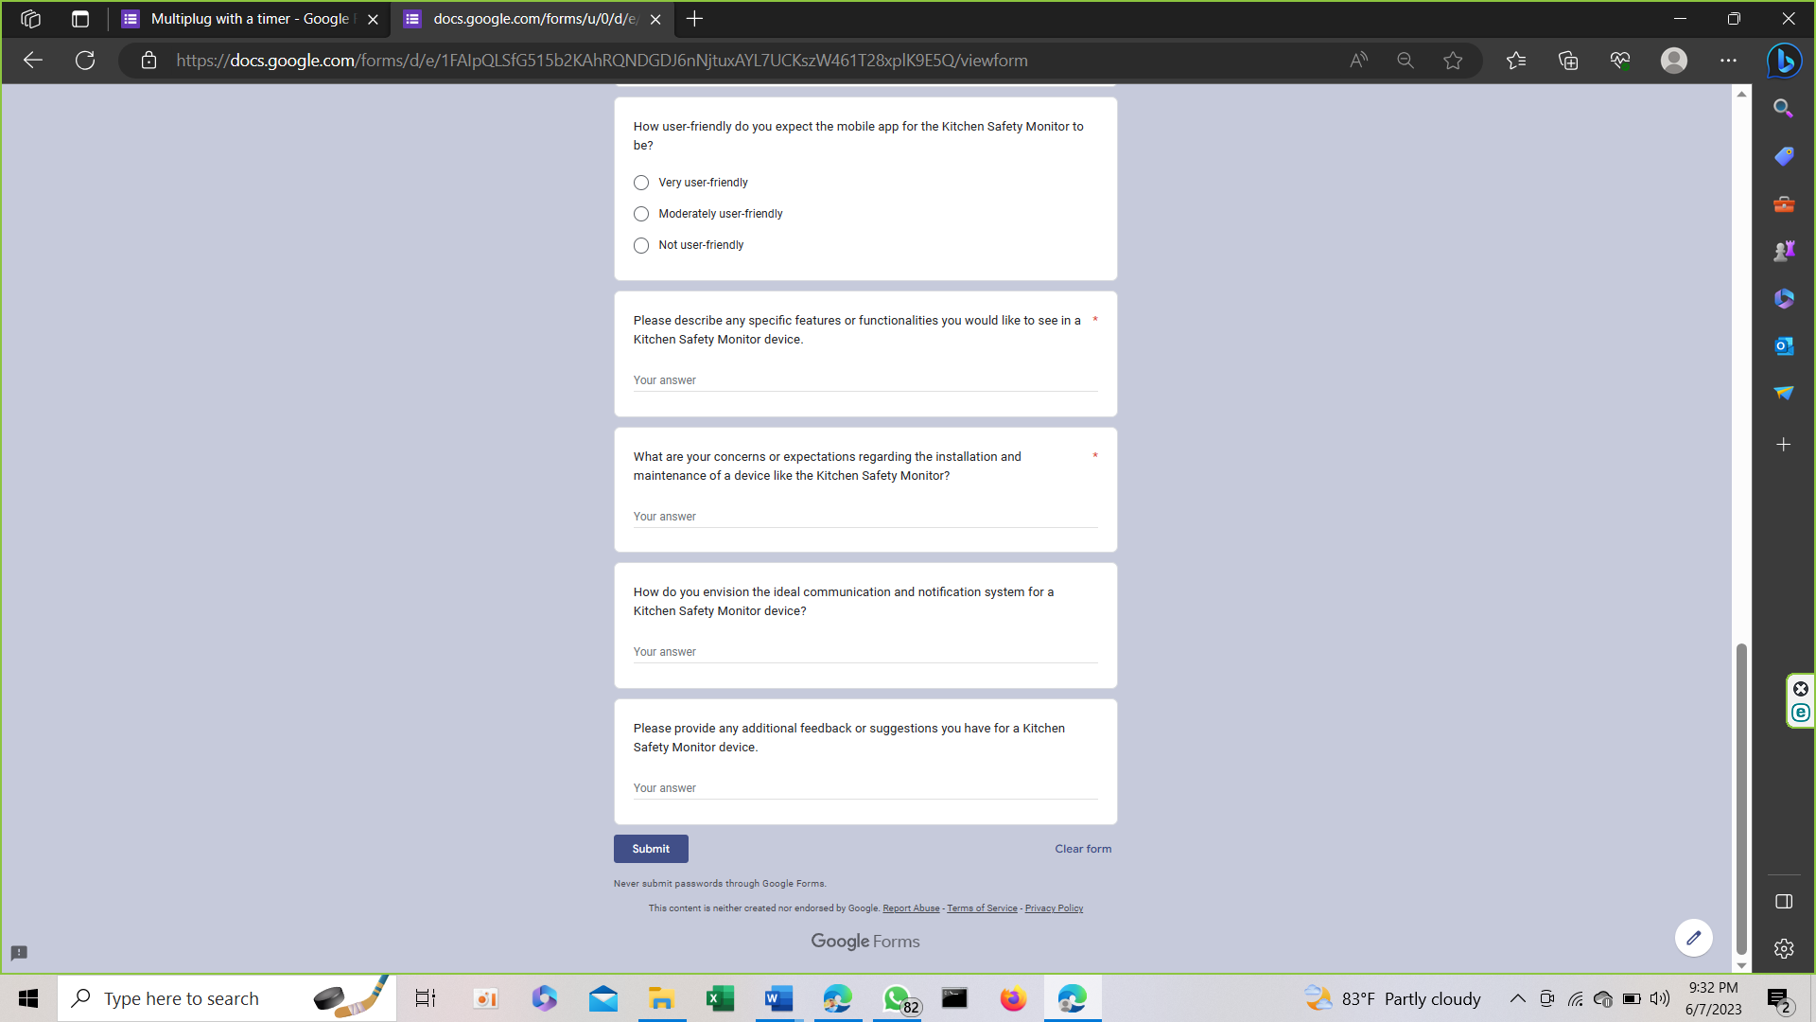

## Survey results

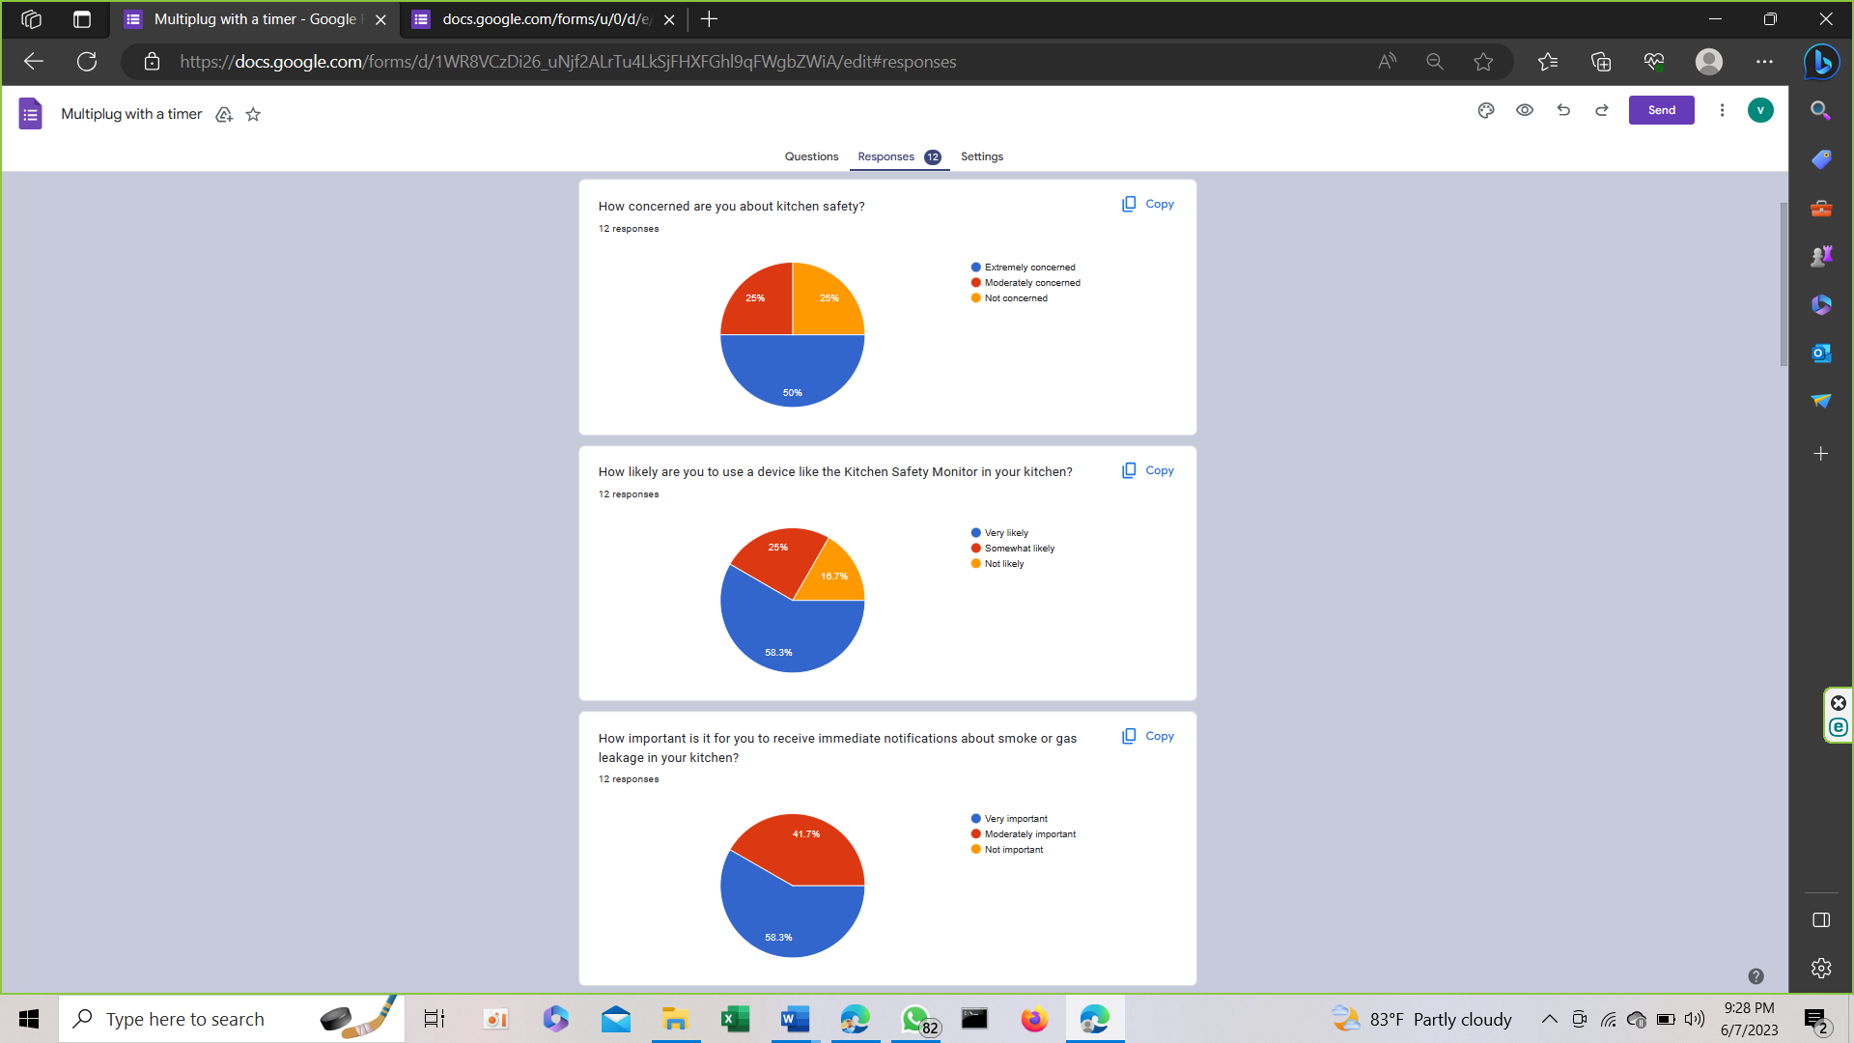

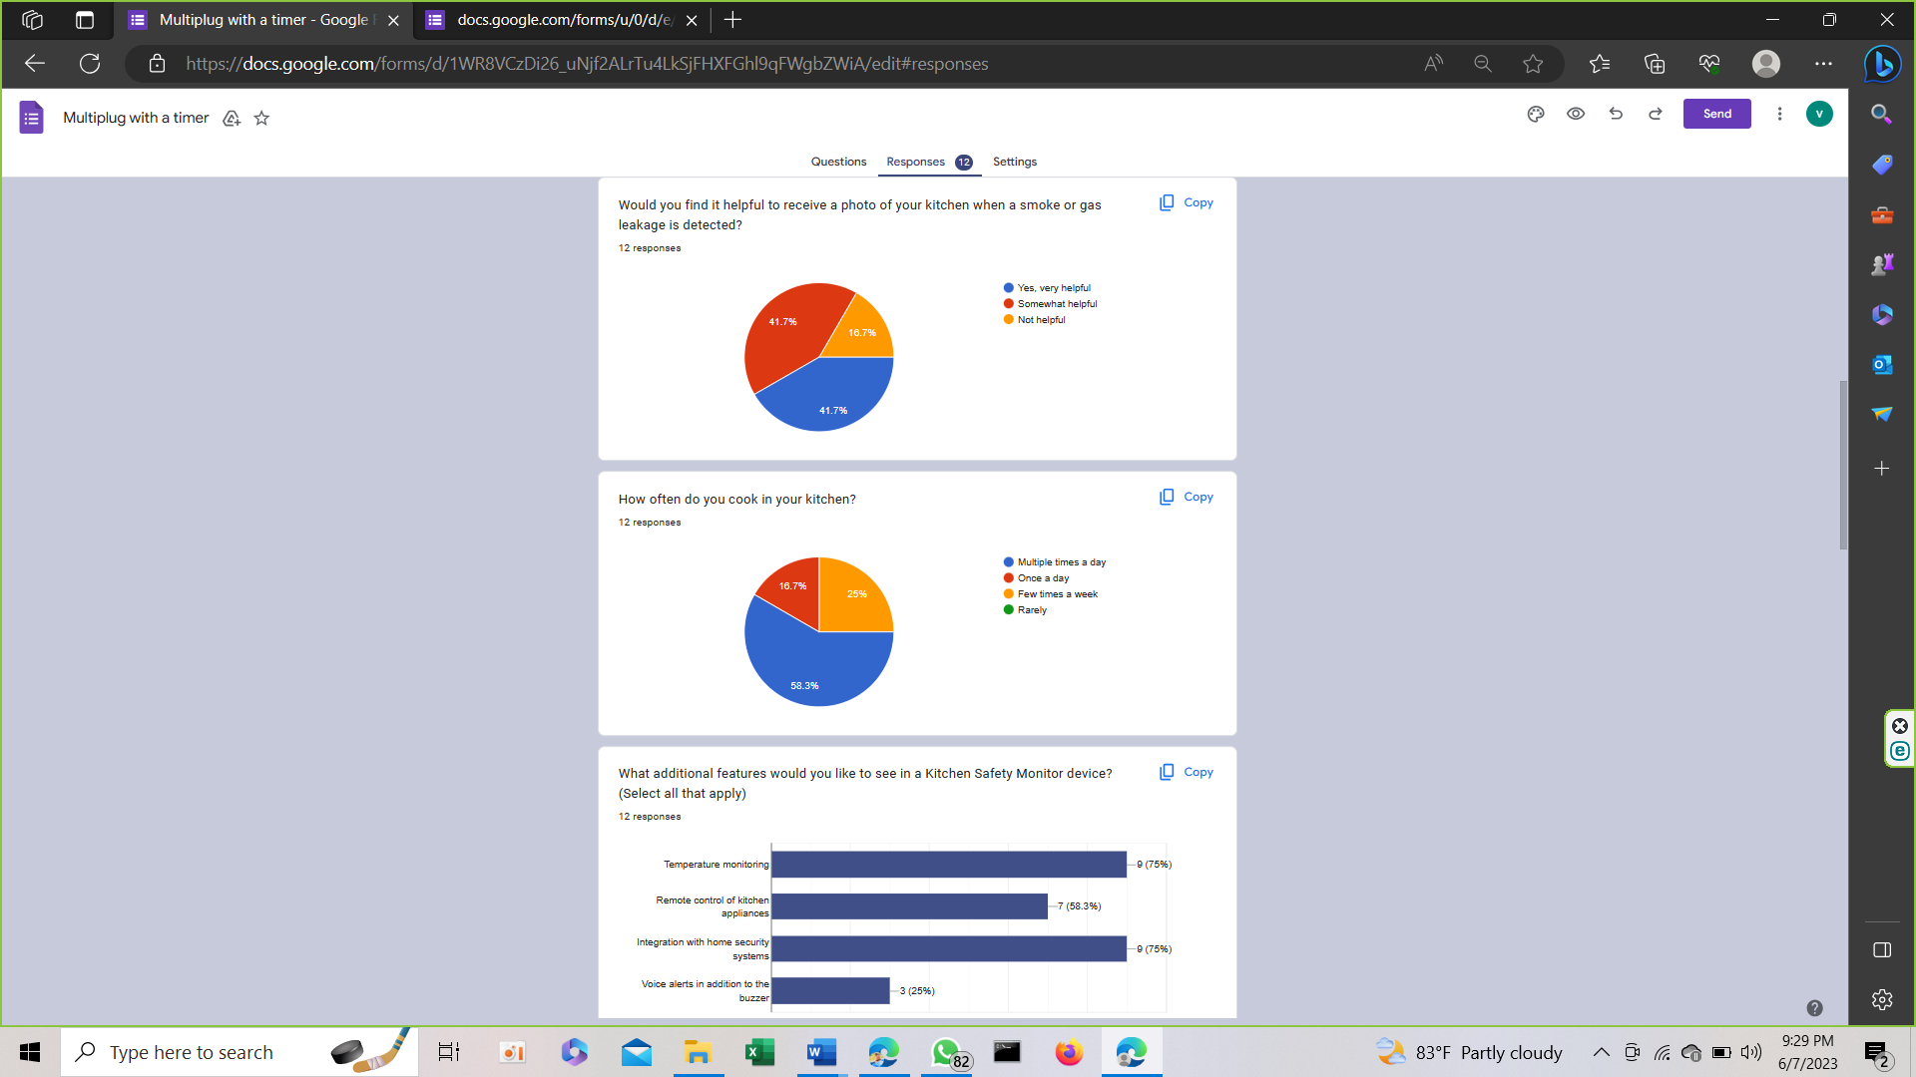

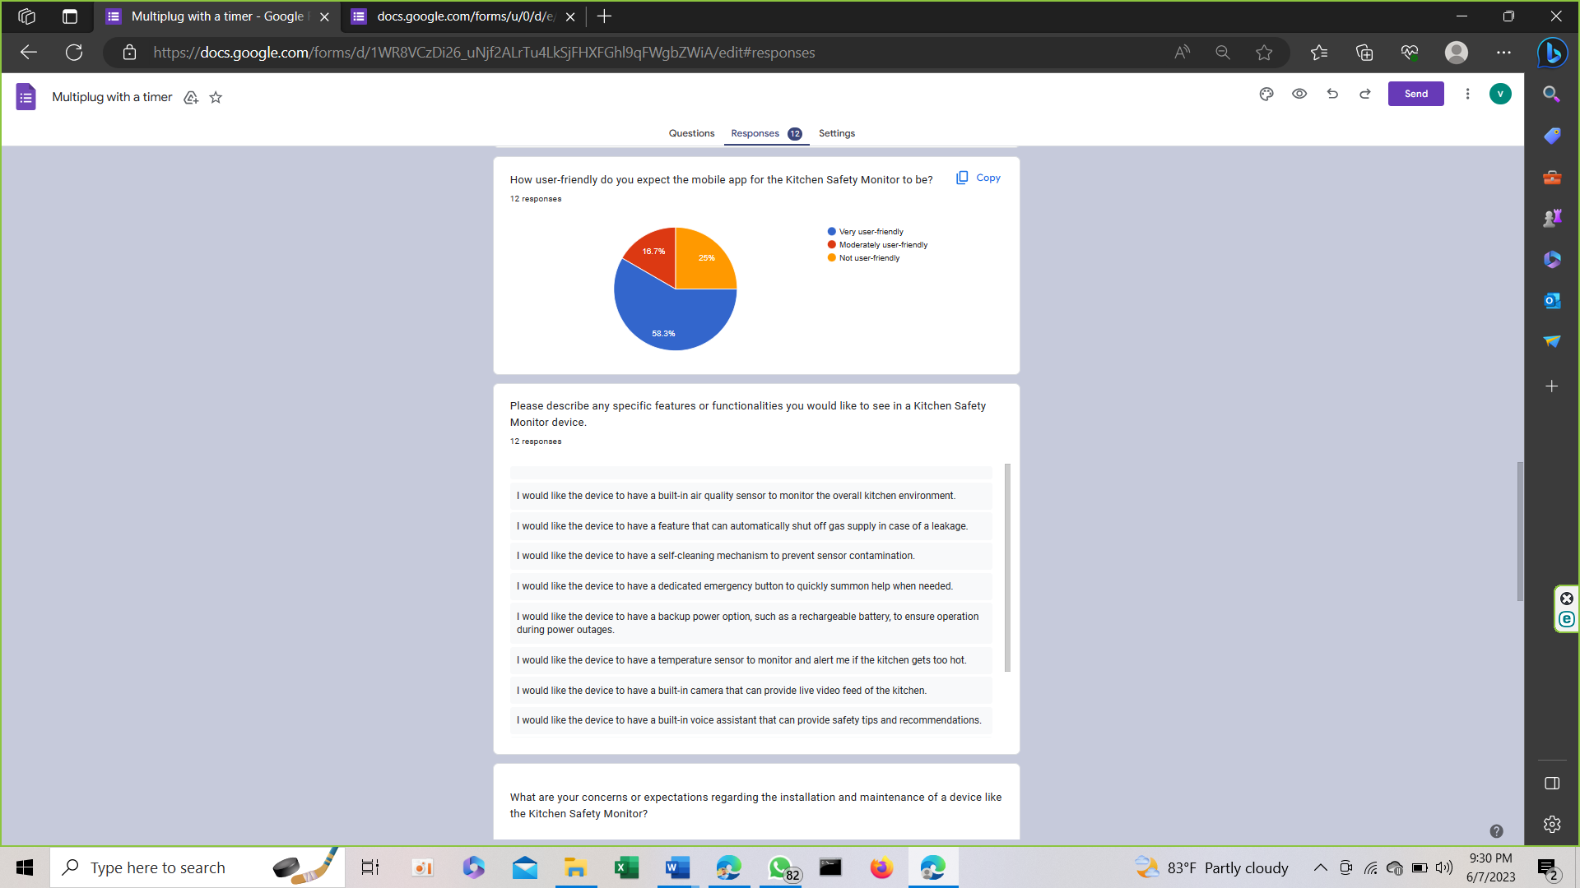

## Some descriptive answers

A student

8. I would like the device to have a built-in air quality sensor to monitor the overall kitchen environment.

9. I am concerned about the device's power consumption and whether it would require frequent battery replacements.

10. I expect the mobile app to have a user-friendly interface with intuitive controls for easy monitoring and configuration.

11. It would be great if the device could integrate with voice assistants like Amazon Alexa or Google Assistant for hands-free control.

A member in the canteen staff

8. I would like the device to have a feature that can automatically shut off gas supply in case of a leakage.

9. I am concerned about the device's durability and whether it can withstand the heat and humidity in the kitchen.

10. I expect the mobile app to provide historical data and trends for better understanding of the kitchen's safety conditions.

11. It would be beneficial if the device could send emergency alerts to pre-defined contacts in case of critical situations.

A member from security division

8. I would like the device to have a self-cleaning mechanism to prevent sensor contamination.

9. I am concerned about the device's compatibility with different types of kitchen layouts and designs.

10. I expect the mobile app to support multiple user accounts with customizable access levels for better household management.

11. It would be great if the device could provide real-time air quality metrics and recommendations for improved ventilation.

A student

8. I would like the device to have a dedicated emergency button to quickly summon help when needed.

9. I am concerned about the device's connectivity and whether it can maintain a stable connection with the mobile app.

10. I expect the mobile app to have multi-language support for wider accessibility.

11. It would be beneficial if the device could integrate with smart lighting systems to automatically turn on lights during emergencies.

# What we changed after getting the user needs.

## Changes in enclosure design

Make the camera adjustable, so the focusing area can be changed.

Include LED s to indicated power to sensors.

## Changes in block diagram

Include LED s indicate the power to sensors.

Dedicated emergency button to quickly summon help when needed.

University of Moratuwa

Department of Electronic & Telecommunication Engineering

Electronic Design realization Solid works submission



# ID_200027R -A.M.V.M.Amarasinghe

### Hand drawn sketches

## Top view

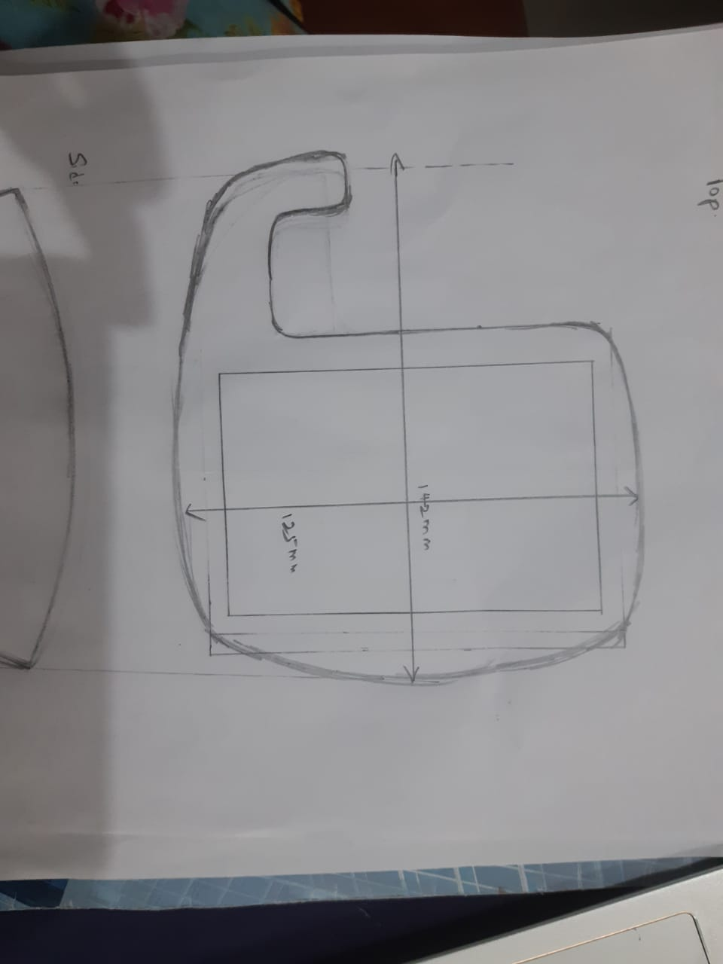

## Side 1 view

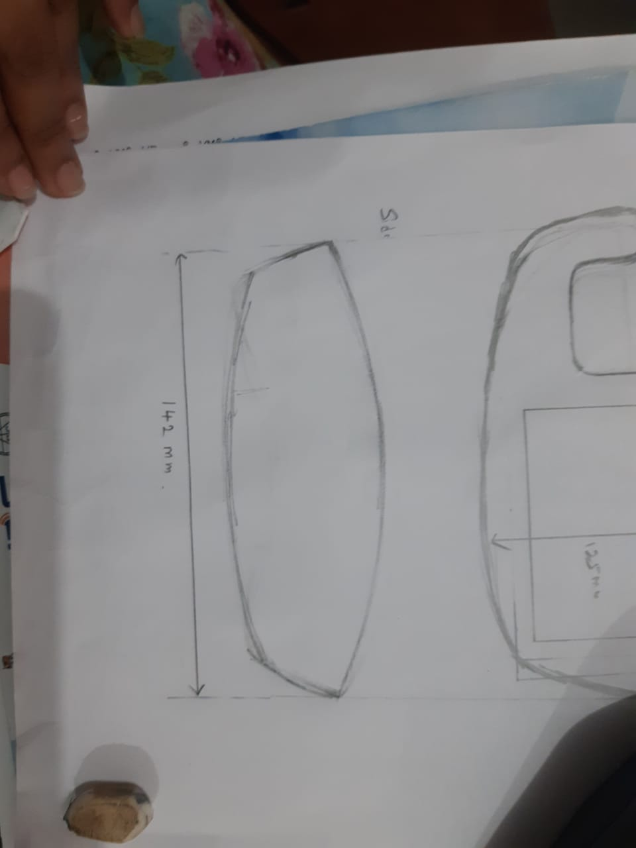

## Side 2 view

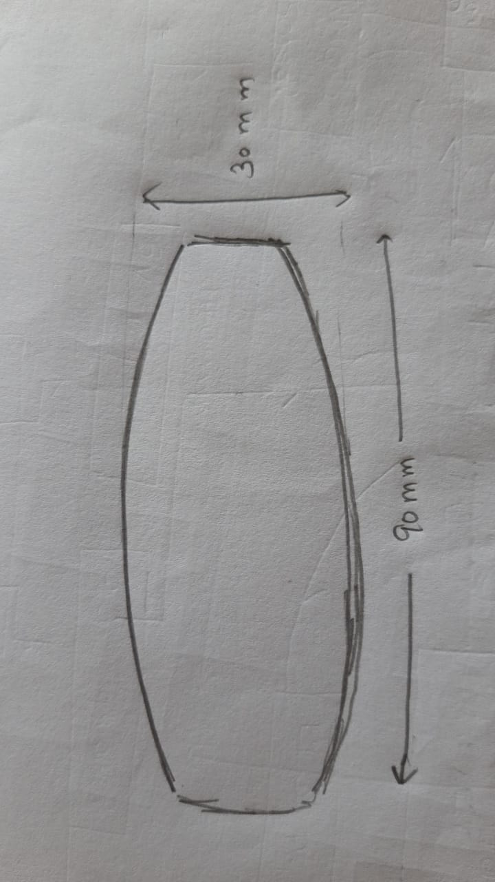

# Solid works model tree

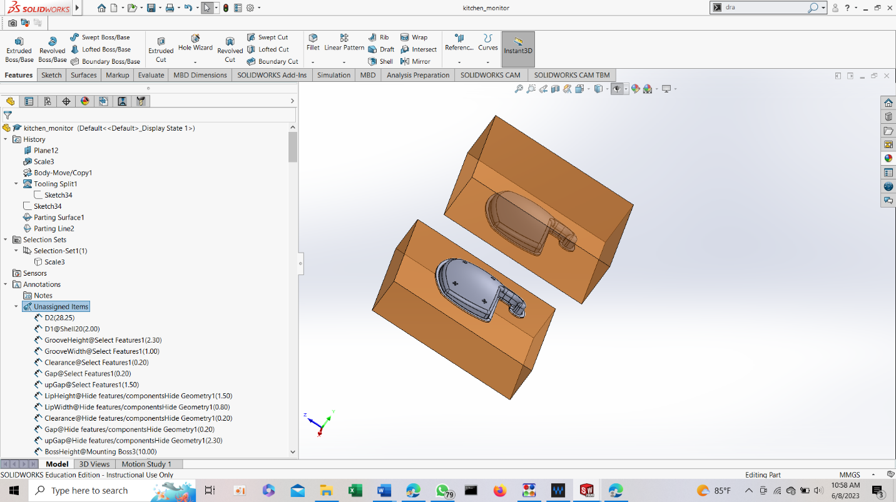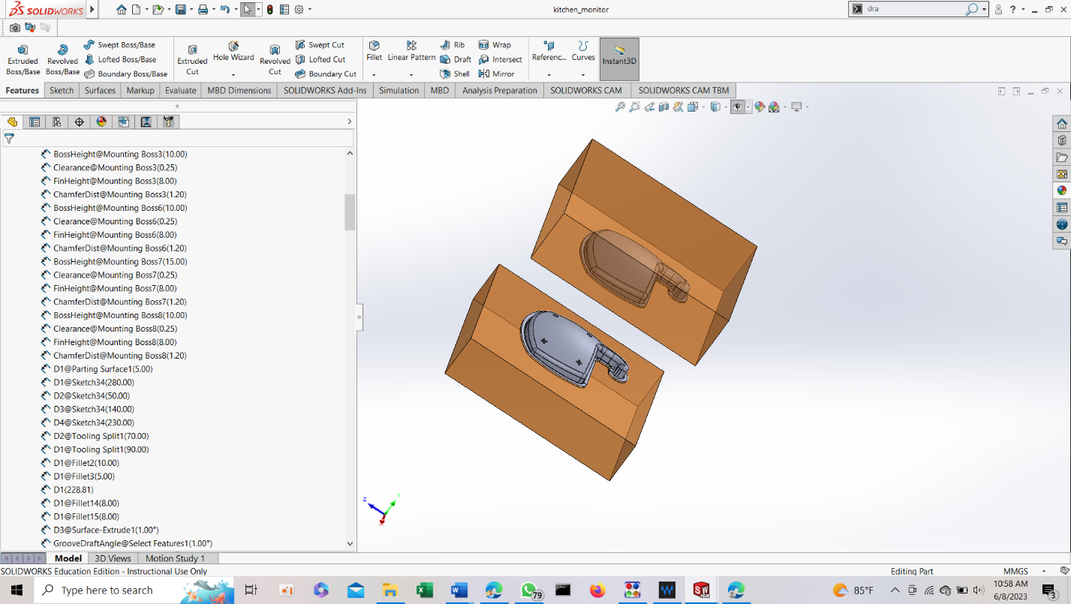

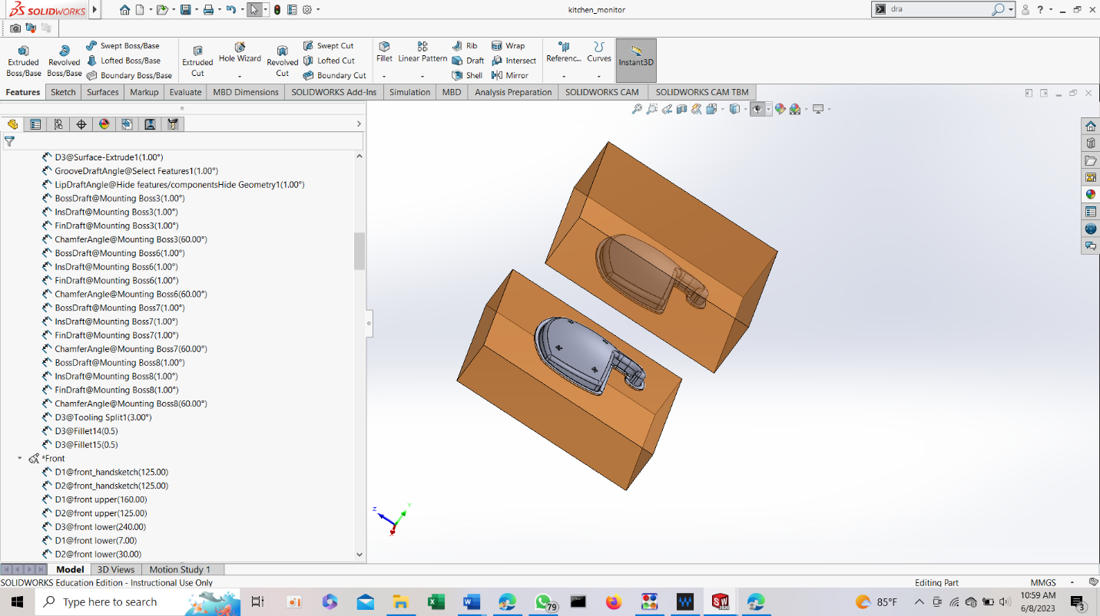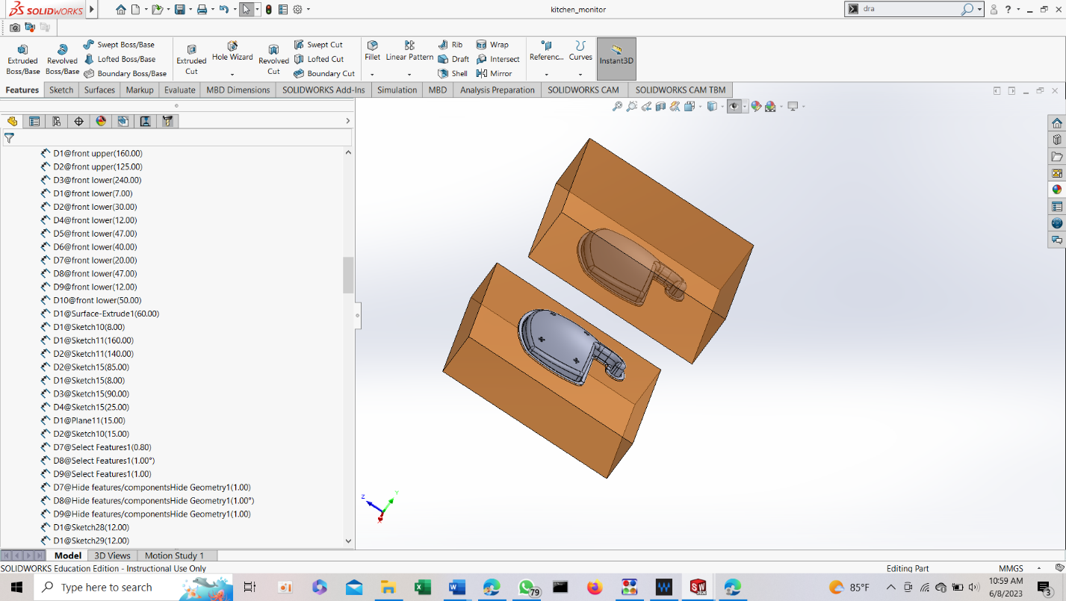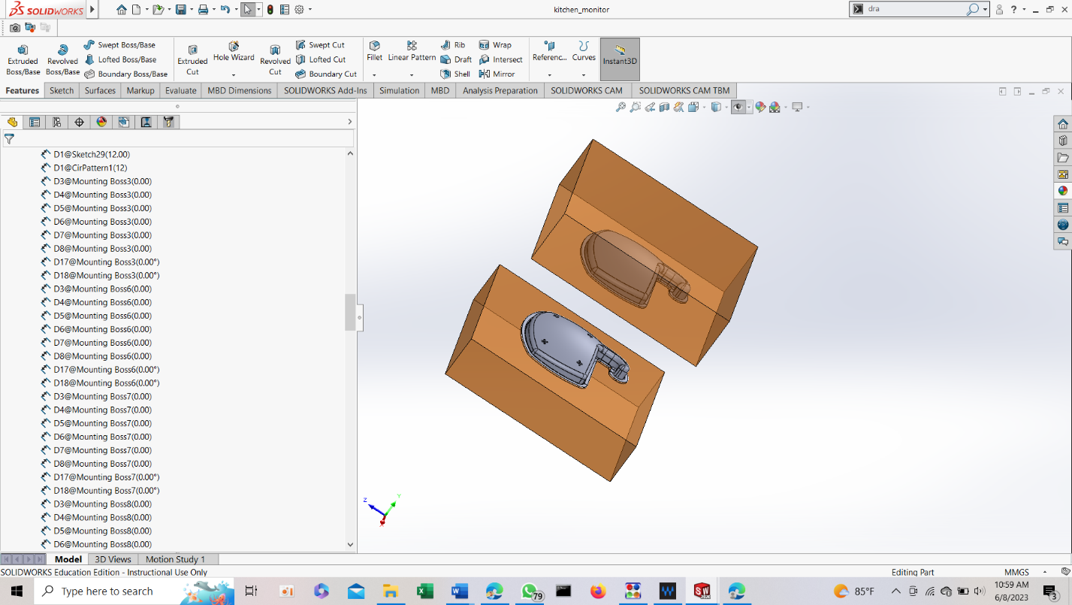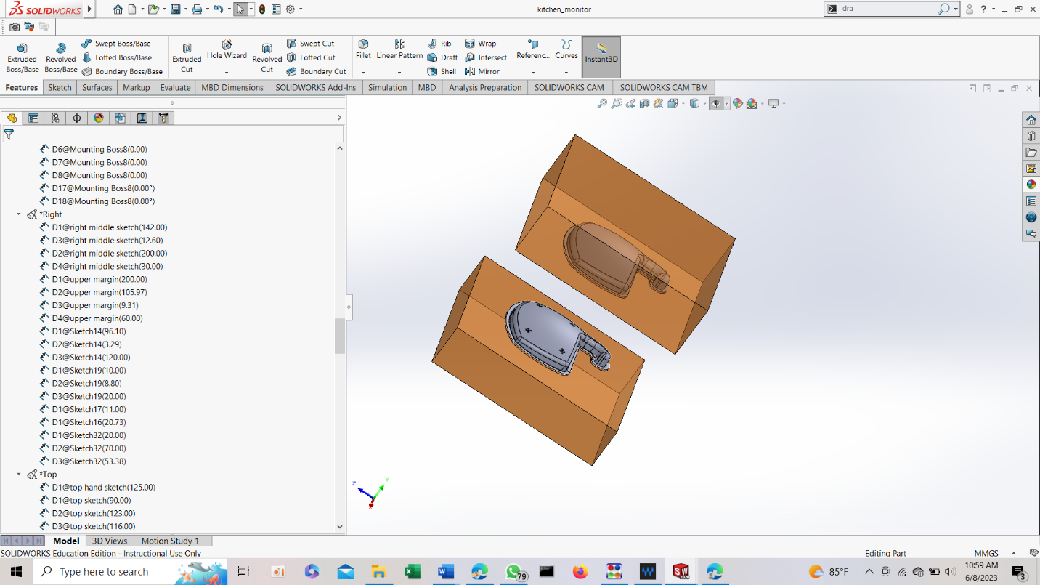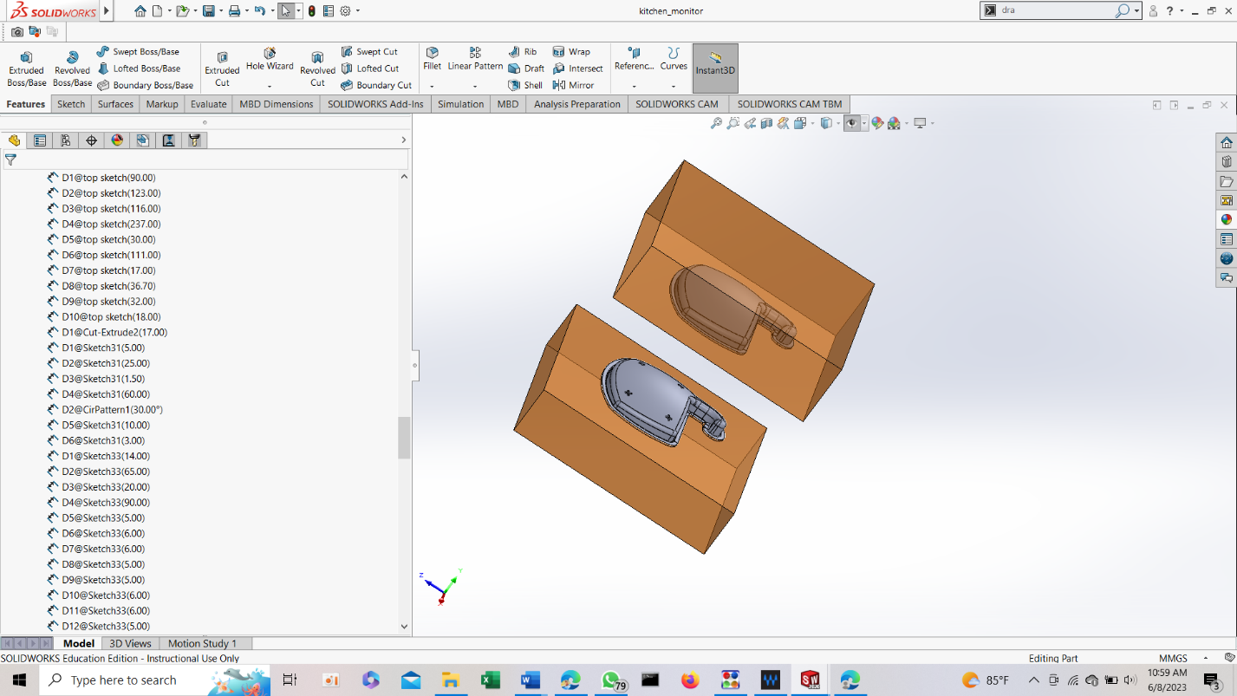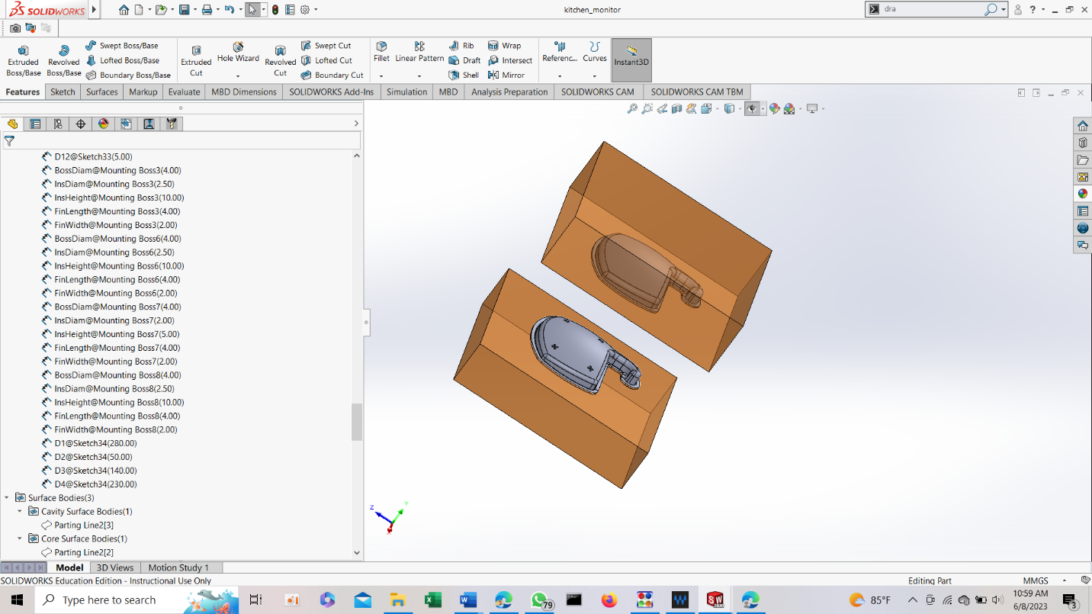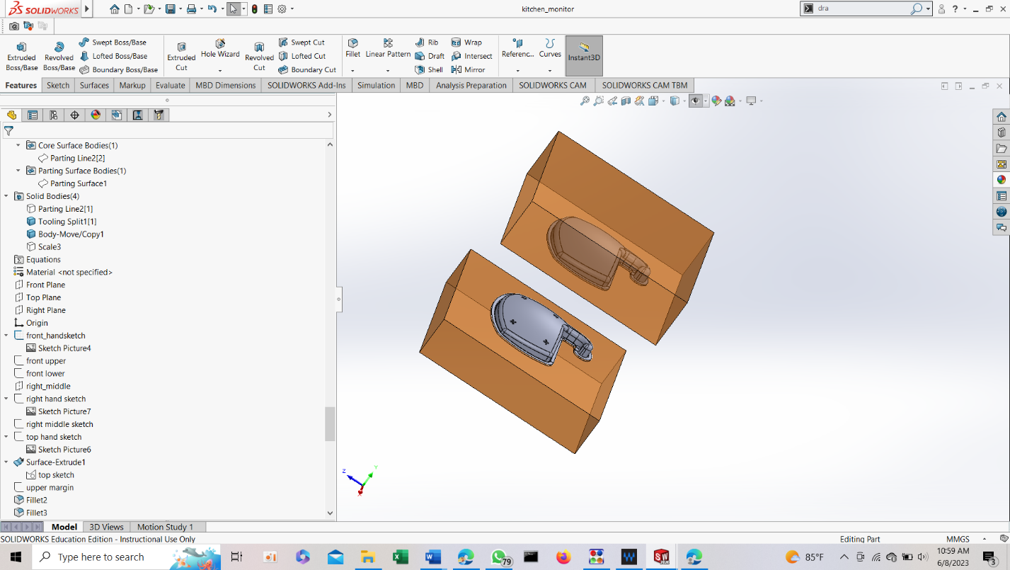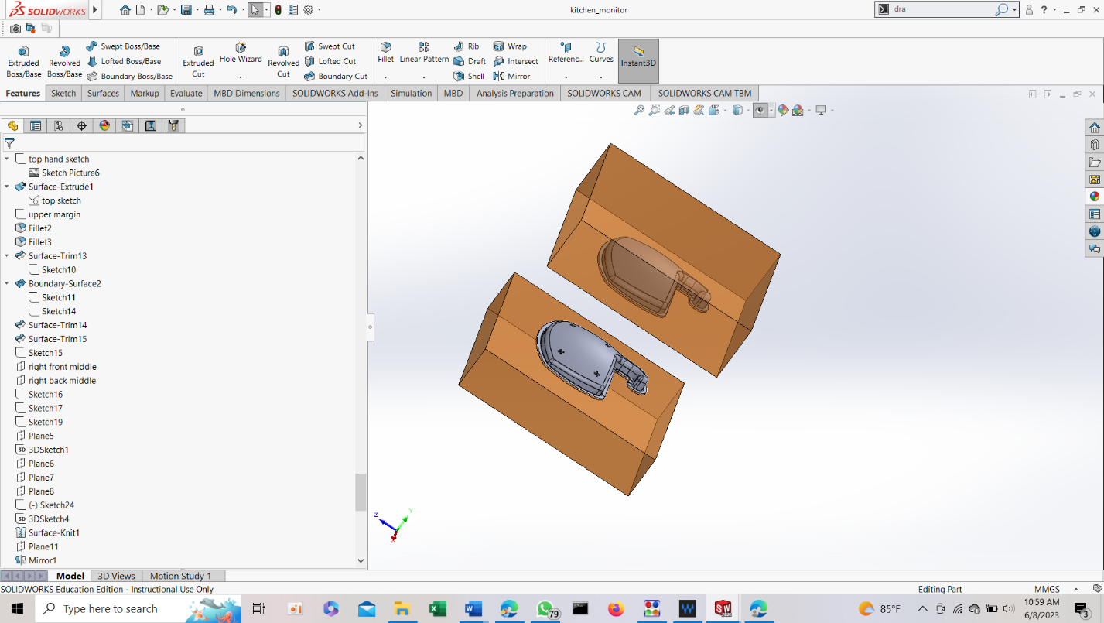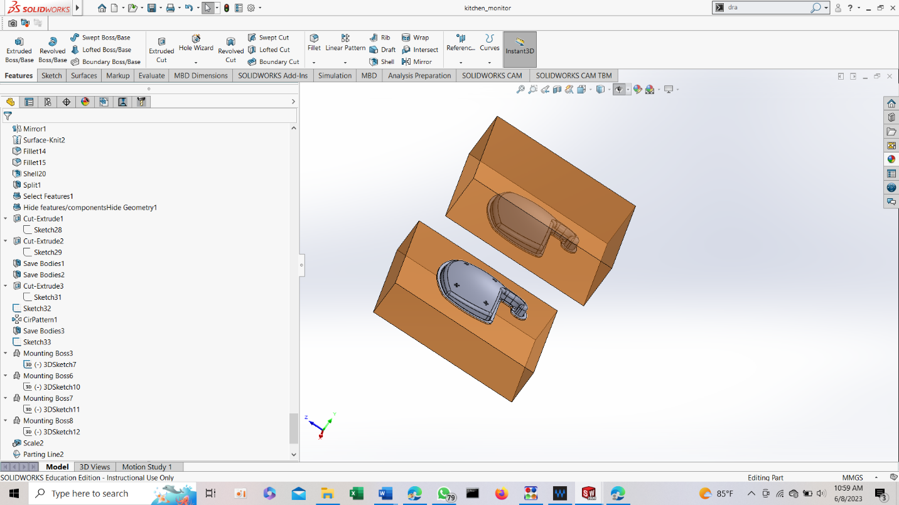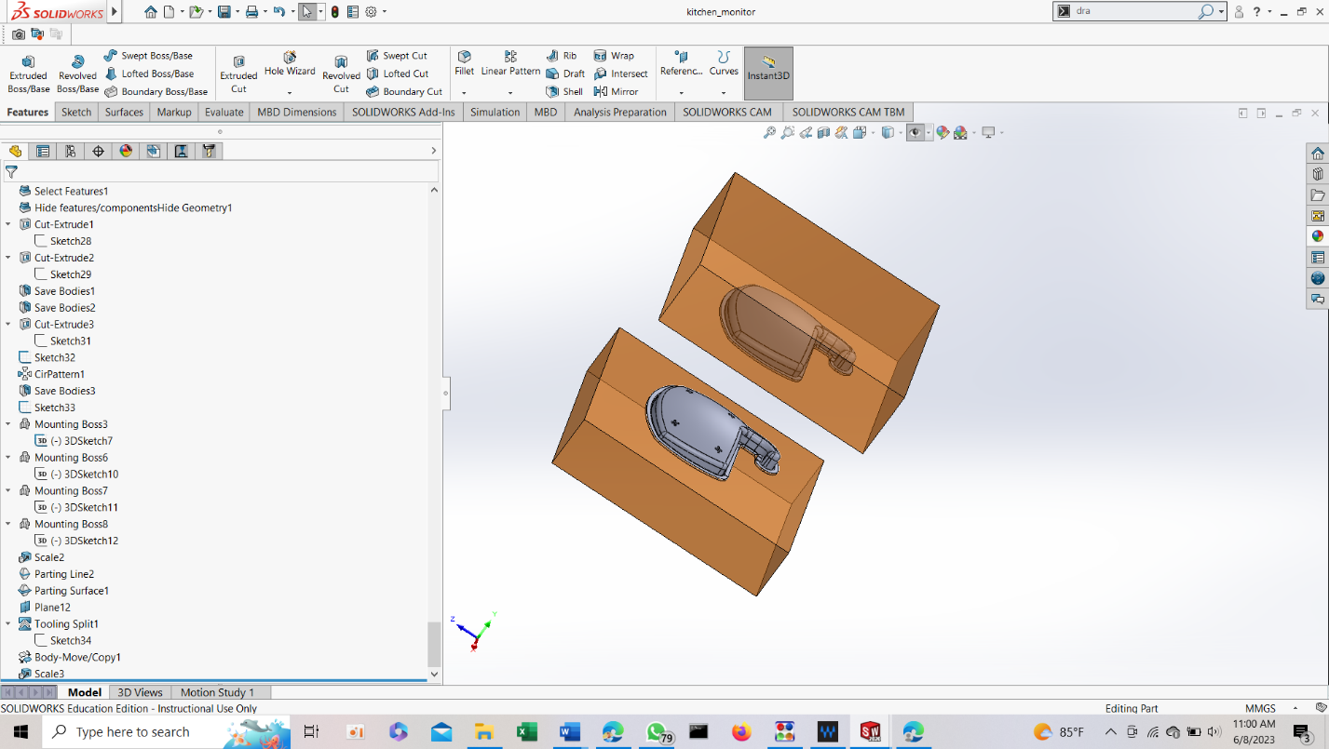

# Solid works

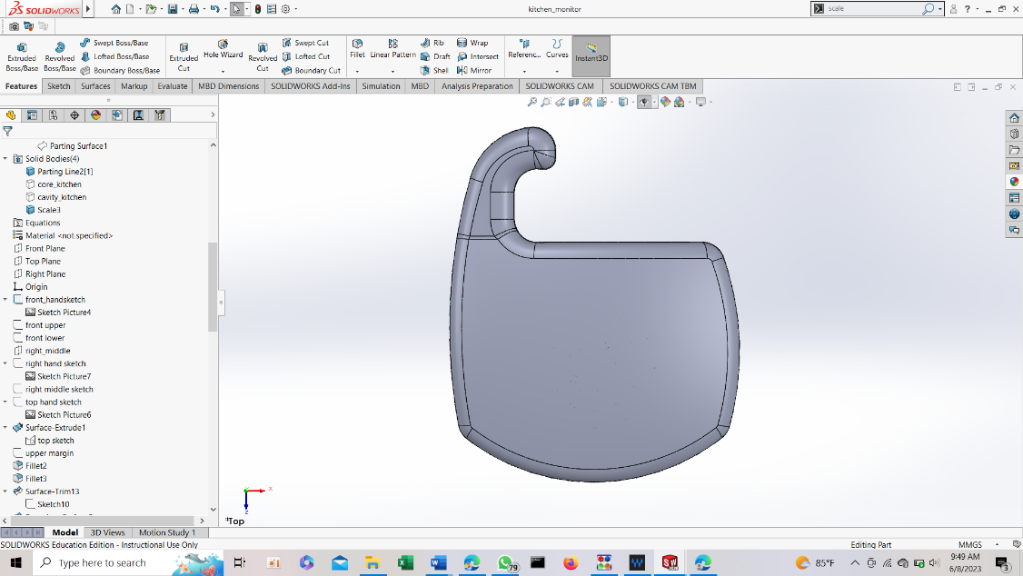

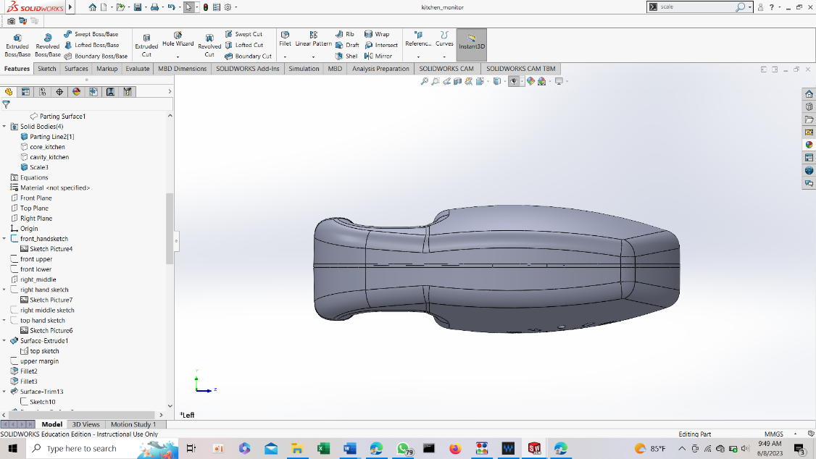

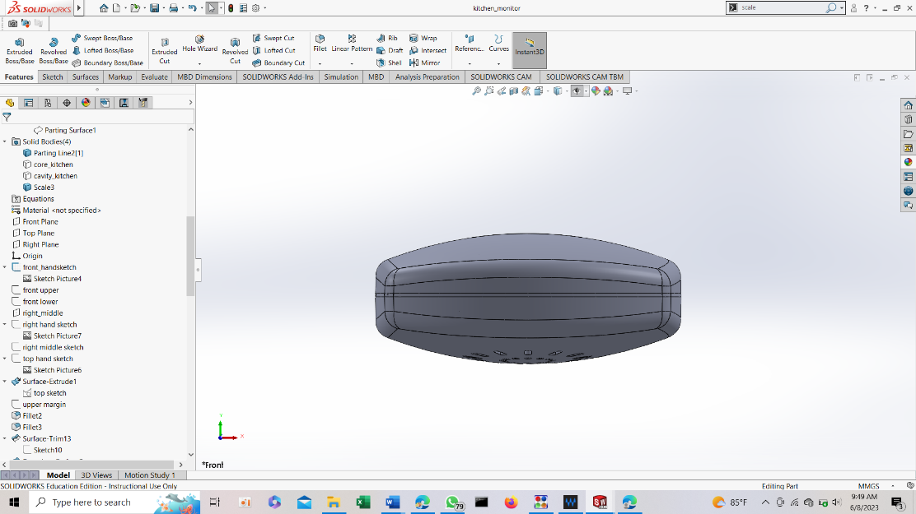

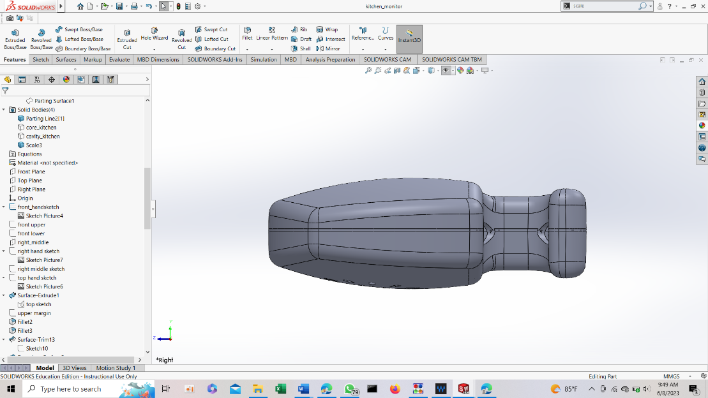

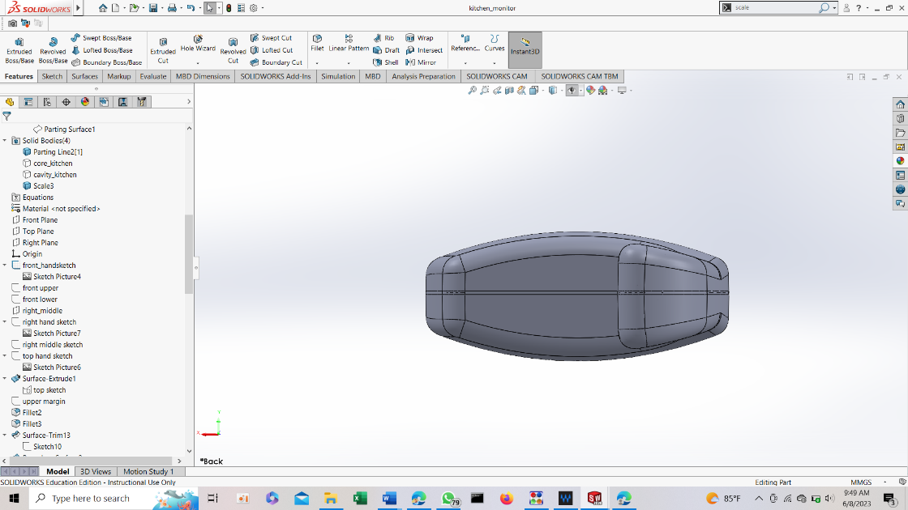

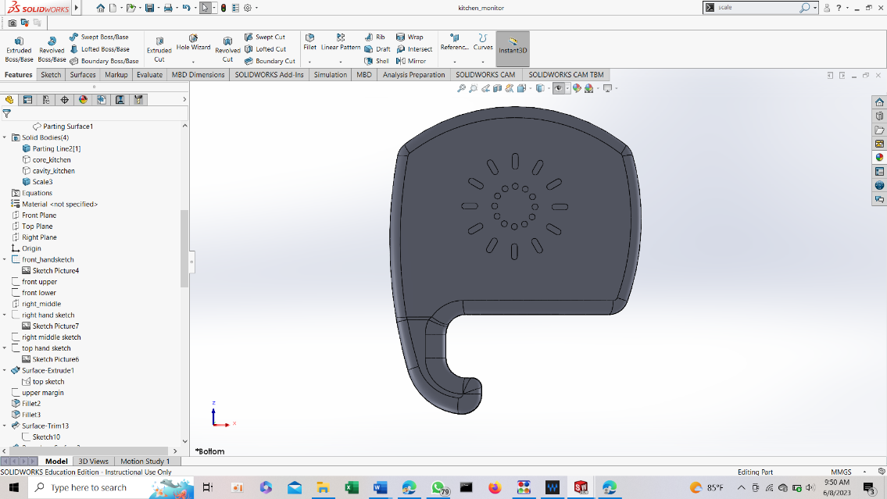

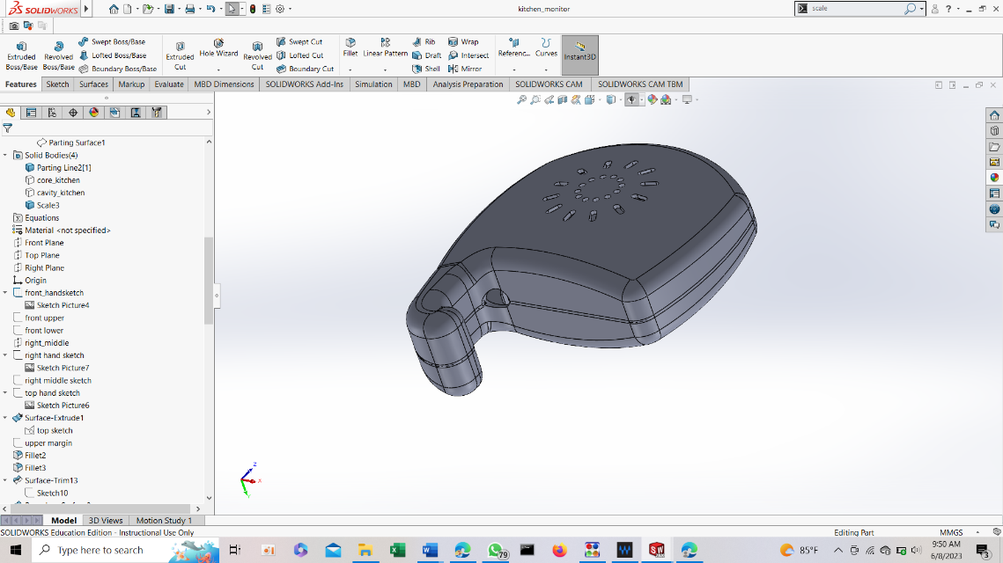

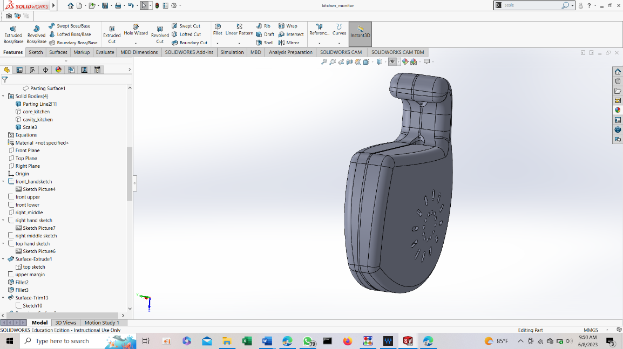

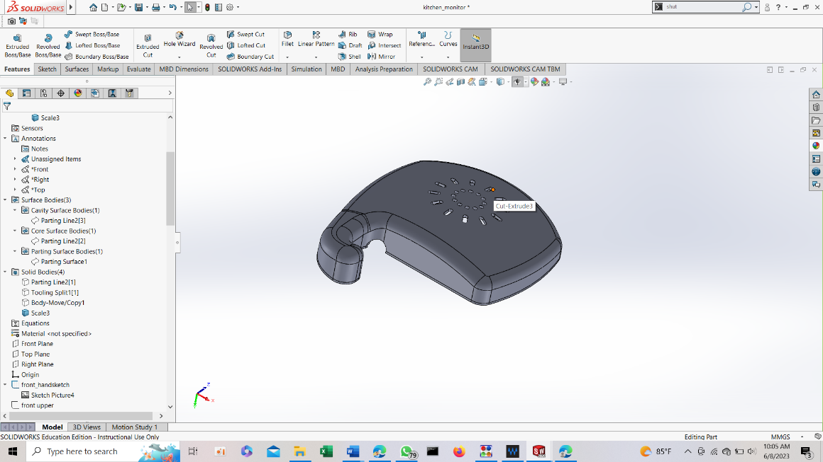

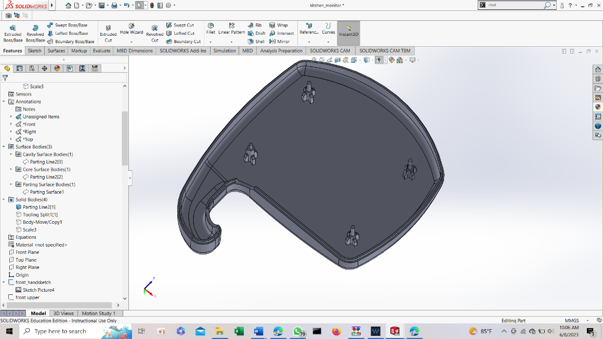

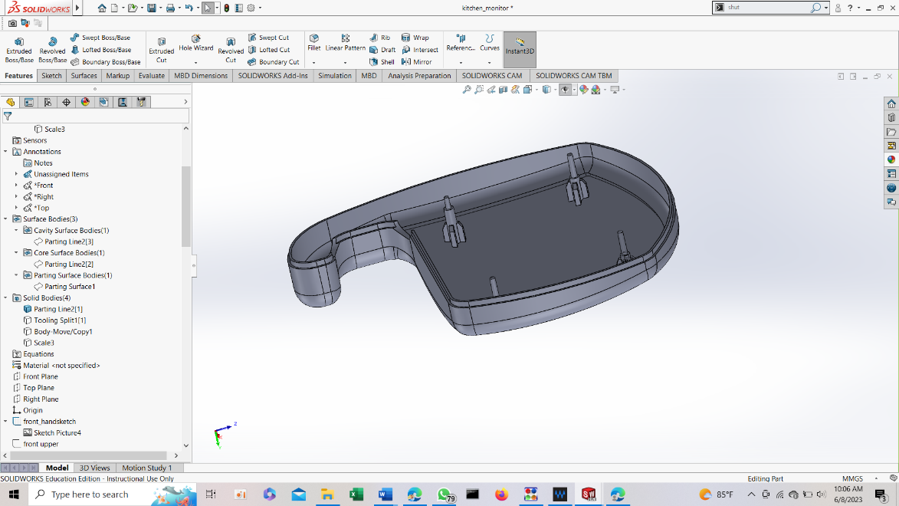

# Draft analysis

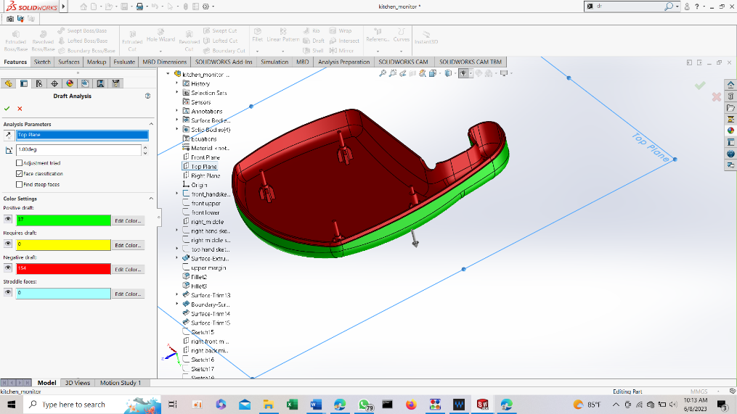

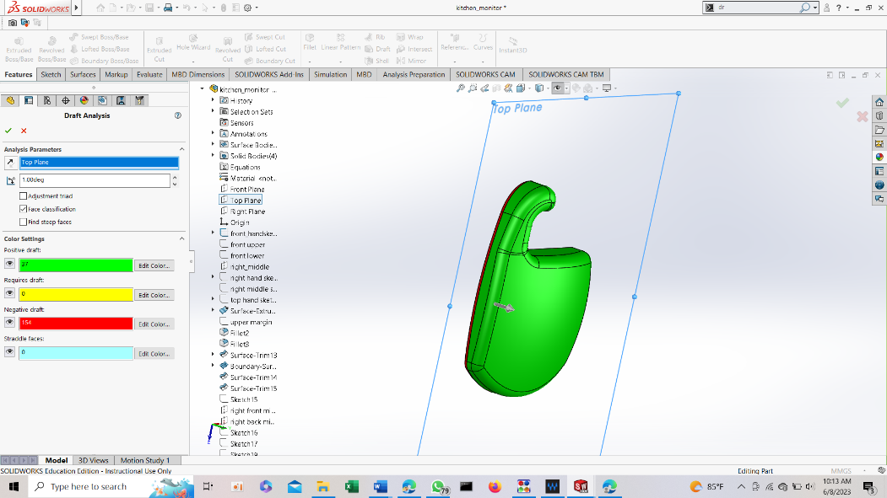

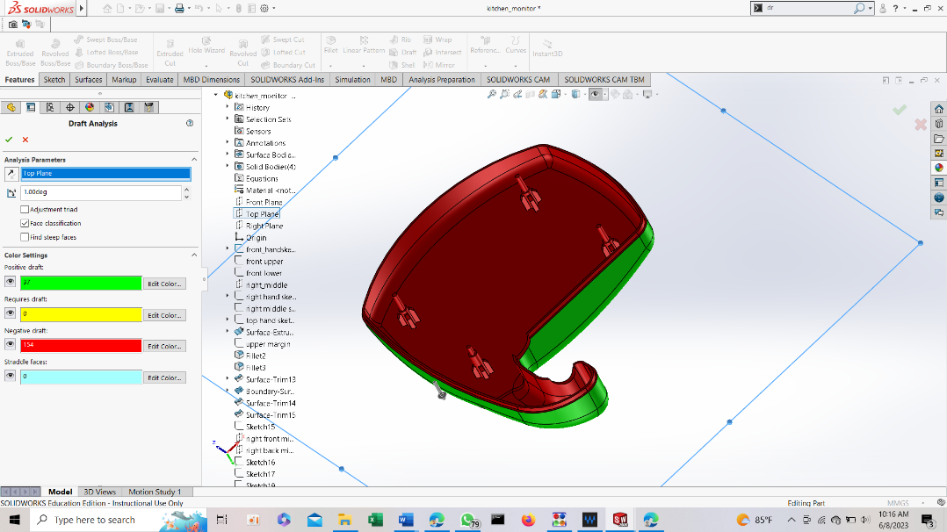

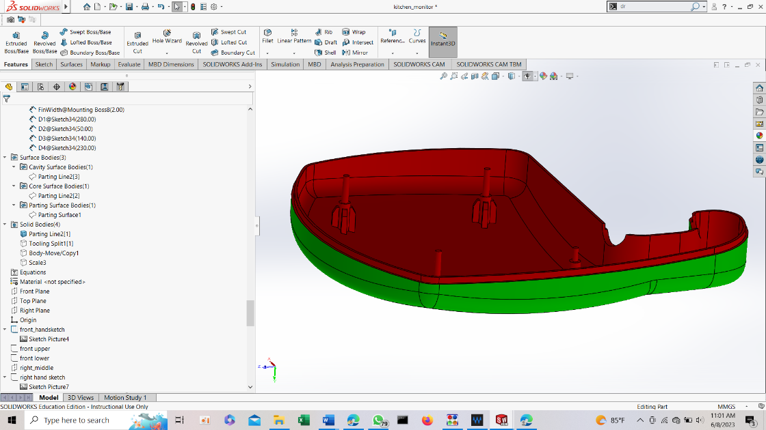

# Mold design

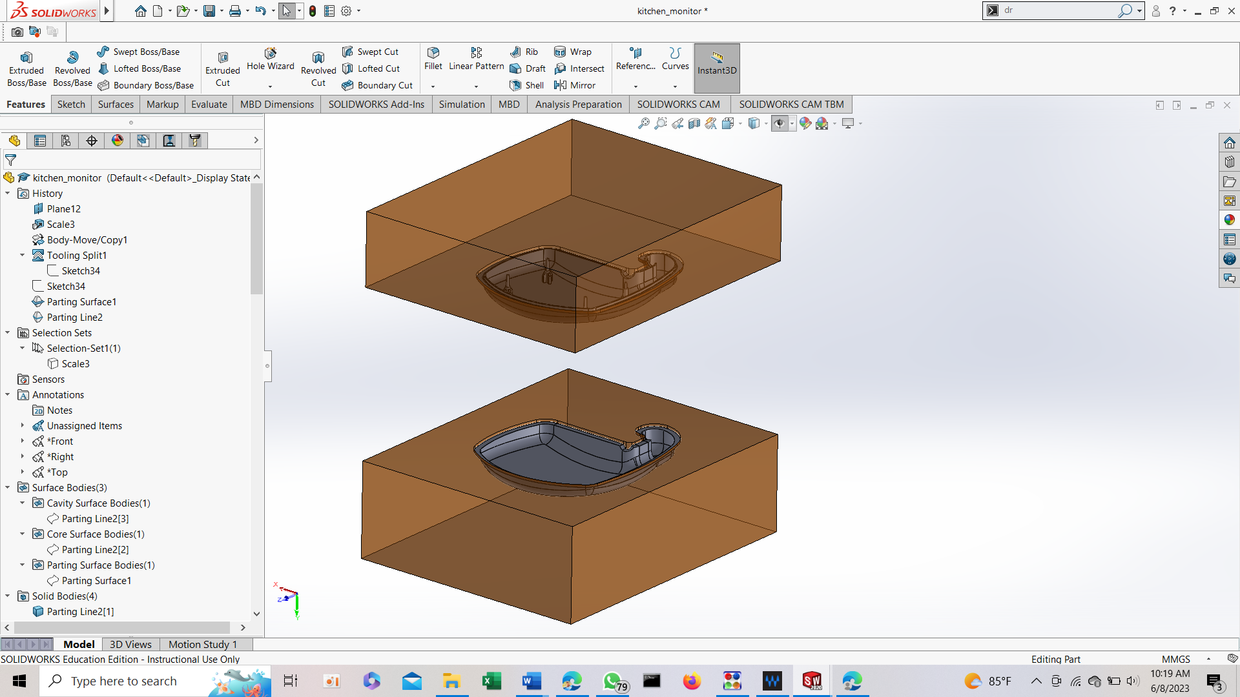

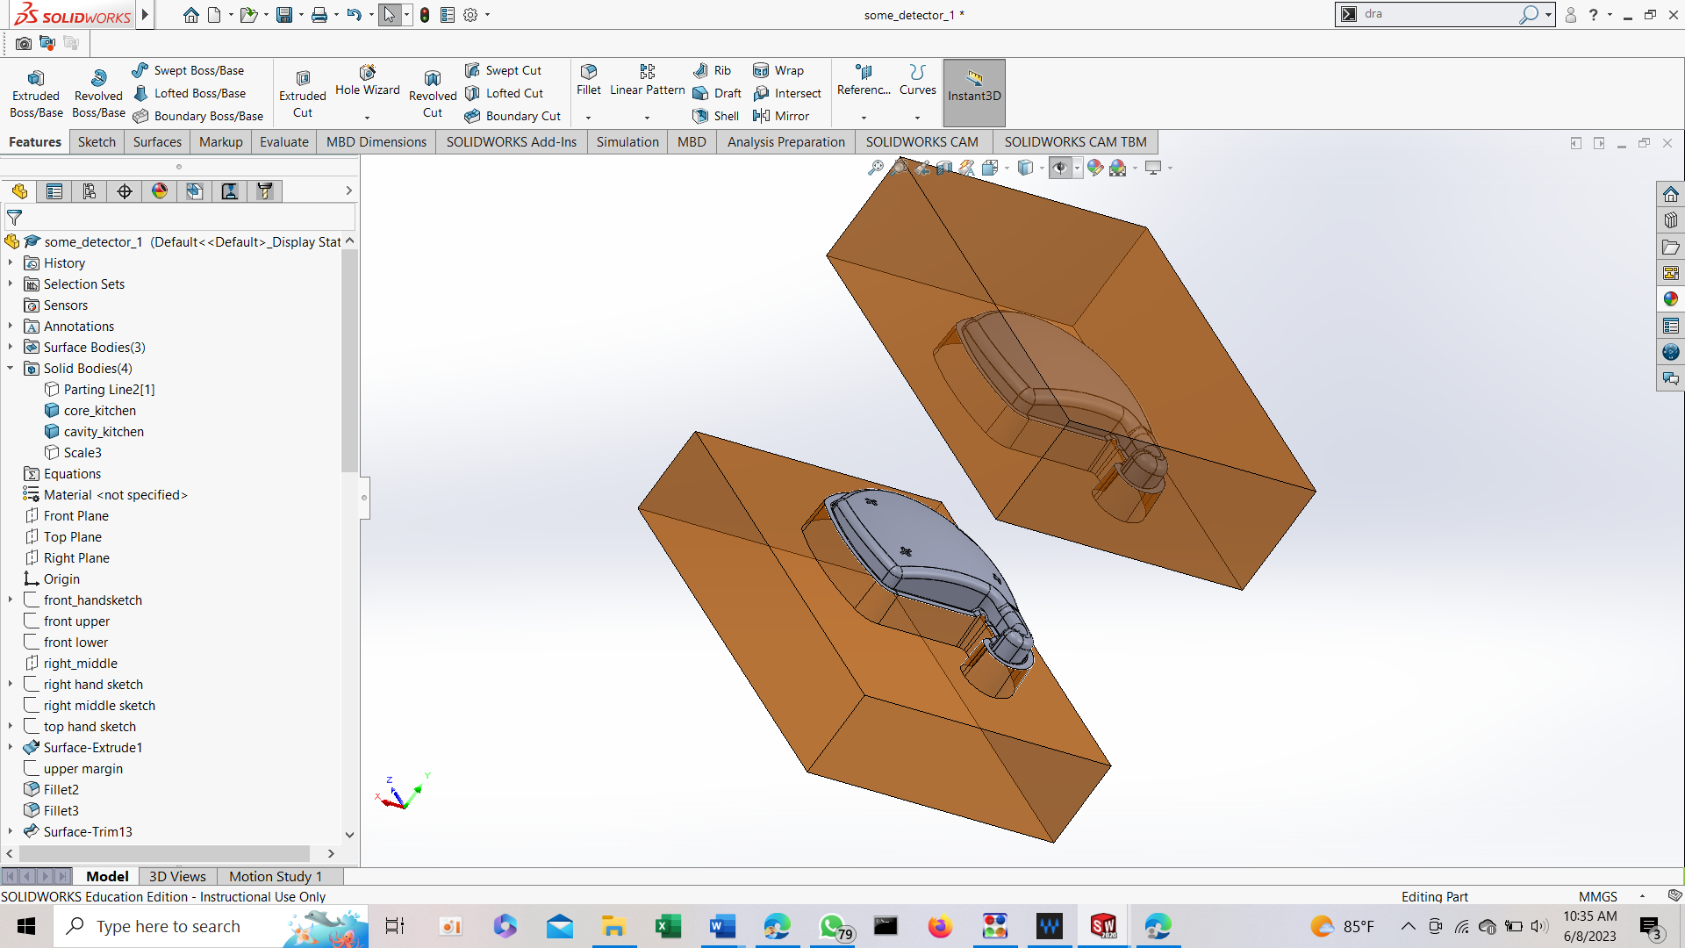

# Mold assemble

